## 

CISC 498 Final Project Documentation

Binobook Website

Tongxu Ge

Mason Chang

Yueyang Liu

Shengan Li

Mar 31th, 2021

## Table of Contents

**User Manual** **4**

1.0 Introduction 4

1.1 Authorized User Division 4

2.0 Website Overview 4

2.0.1 Book Information Page 4

2.0.2 Book Customization 5

2.0.3 Book Category 5

2.0.4 Shopping Cart 6

2.0.5 Payment 6

2.0.6 Download 7

3.0 Administrator System 7

3.0.1 Login 7

3.0.2 Welcome Page 7

3.0.3 Goods Management 8

Add a Book 8

Pagination 9

Modify a Book 9

Modify a Book Element 10

Set Book Content 11

3.0.4 Category Management 12

Modify Element Category 12

Delete Element Category 13

3.0.5 Account management 14

4.0 Customer and Staff Management 15

4.0.1 Customer Management 15

Register 15

Login 15

Manage User Information 16

View an Order 16

Logout 16

5.0 File Management 16

5.0.1 File Storage 16

**Developer Maunal** **17**

1.0 Backend Service Overview 17

1.1 Swagger-UI (Interactive API Document) 19

1.2 Book Customization 19

1.3 Book Preview 20

1.4 Security Control 21

1.4.1 User Token 21

1.4.2 Authentication 22

1.4.3 Authorization 22

2.0 Frontend 23

2.0.1 Project Structure 23

2.0.2 Import UI Elements 24

2.0.3 Routing 24

**Installation Guide** **25**

1.0 Environment Setup 25

Configure jdk1.8 25

Configure tomcat 8.5.61 26

Configure apache 2 26

Configure MySQL 26

Configure PhpMyAdmin 26

Configure MINIO 27

Configure the server firewall 27

1.1 Build and Deployment 27

1.1.1 Backend 27

Code Environment 27

Server Setup 28

1.1.2 Frontend 29

Code Setup 29

Server Setup 30

Access the Website 30

**Maintenance Suggestions** **31**

**Limitations and Workarounds** **31**

UI Design 31

Adapativity 32

File Storage 32

Portability 32

**Updates to previous documents** **32**

**References** **32**

**Work Distribution** **32**

## User Manual

### 1.0 Introduction

The binobook team may use the binobook online shopping website to sell customized children's ebooks. Parents and children can choose to generate their own book on the website and will be able to directly download the personalized ebook after payment. The website allows parents and children to customize the book characters in terms of skin tone, hair color and name.

This document guides a user through the necessary steps to get a customized e-book from the website.

### 1.1 Authorized User Division

The binobook website has basically three types of users with different roles and permissions as follows:

1. **Web administrator or the Binibook team**

Have permission in adding, deleting, updating the website ebooks, searching ebooks, managing book categories, creating and managing user accounts, customizing ebooks and managing the images used in the website.

1. **Parents or Teachers**

Have access to select and buy the preferred ebooks from the website, customize their ebooks, pay for ebooks, preview the customized ebooks and receive a copy of their ebooks in their email address after payment.

1. **Children**

Have access to select and customize their ebooks based on their preference on the book character’s skin tone and hair color.

### 2.0 Website Overview

#### 2.0.1 Book Information Page

Users can get the detailed book description with the product card on the homepage or product page. Users and customers can access the product page by simply **clicking** the **Personalize** button on the homepage or product card.

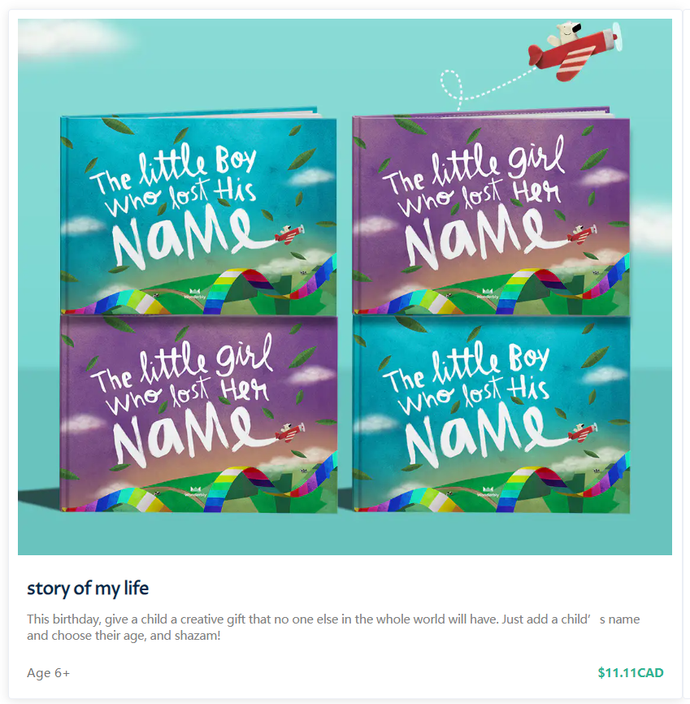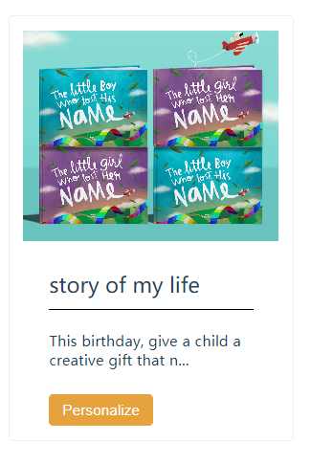

*Product Card(All Book Page) Product Card(Homepage)*

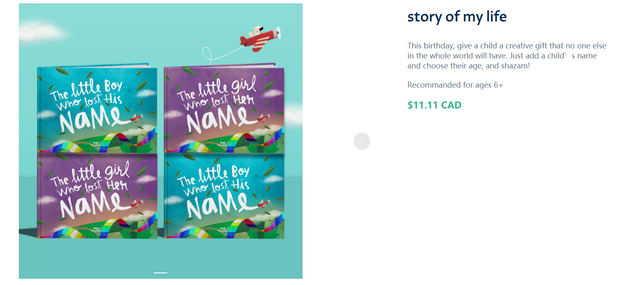

*Product Page*

#### 2.0.2 Book Customization

Customers are able to choose personalization options on a detailed product page. Users are able to customize **Skin Tone**, **Hair Color**, and **typing the child’s name**. Once they finish this step, they can **preview** the story books which show the first two pages of the story books.

Notice: 1. The preview button is disabled only if the customer fills the information and a warning message is shown on the page.

2.This section for books sold out is disabled for selection, the preview button and add to cart button is disabled as well.

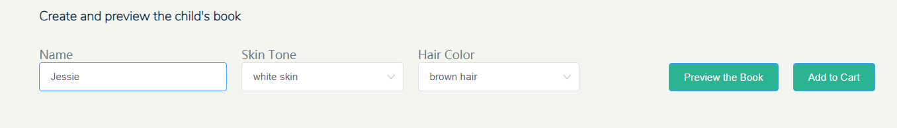

*Book Customization Form*

#### 2.0.3 Book Category

Storybooks are classified into three categories, and users can search for the books with the book category. The user could view the category page by **clicking** the **tags** on the menu and navigate to a page which is similar to the product page for selected category books.

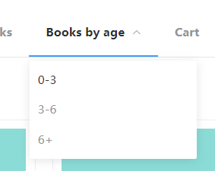

*Book Category Tags*

#### 2.0.4 Shopping Cart

The Binobook website allows users to store their favourite books in the shopping cart. Customers can add their favourite book through a book detail page. Carts can be edited on the Cart page which can be reached through the cart tag on the navigation bar by clicking the **delete** button on the Cart page or navigate to the book detail page by clicking the **personalize** button.

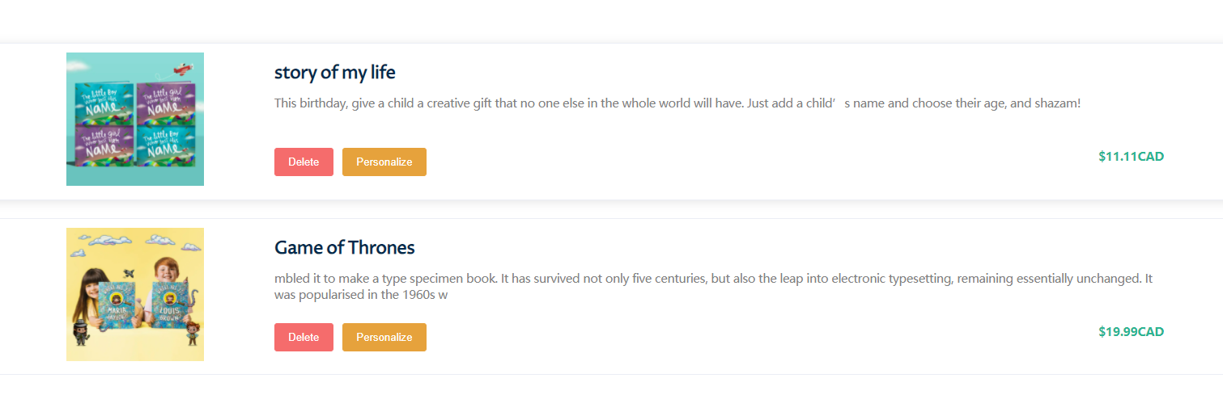

#### 2.0.5 Payment

Purchasing is enabled on the preview page, where users can redirect to a payment gateway such as CIBC online payment.

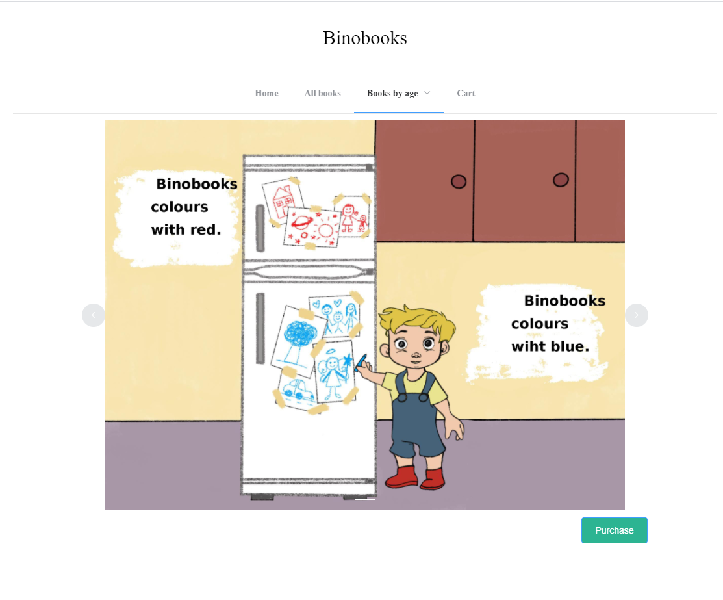

*Preview Page with Purchase Button on Right Bottom Corner*

#### 2.0.6 Download

After payment is validated by the external system, the confirmation page pops up and the user can **download** the full storybook by **clicking** the **download** **button**.



*Confirmation Page with Download Link*

### 3.0 Administrator System

#### 3.0.1 Login

The administrator can log in to the system by typing the preset account with the correct **username** and **password** which is stored in the database. Any attempt to access the home page directly will be directed back to the login page.

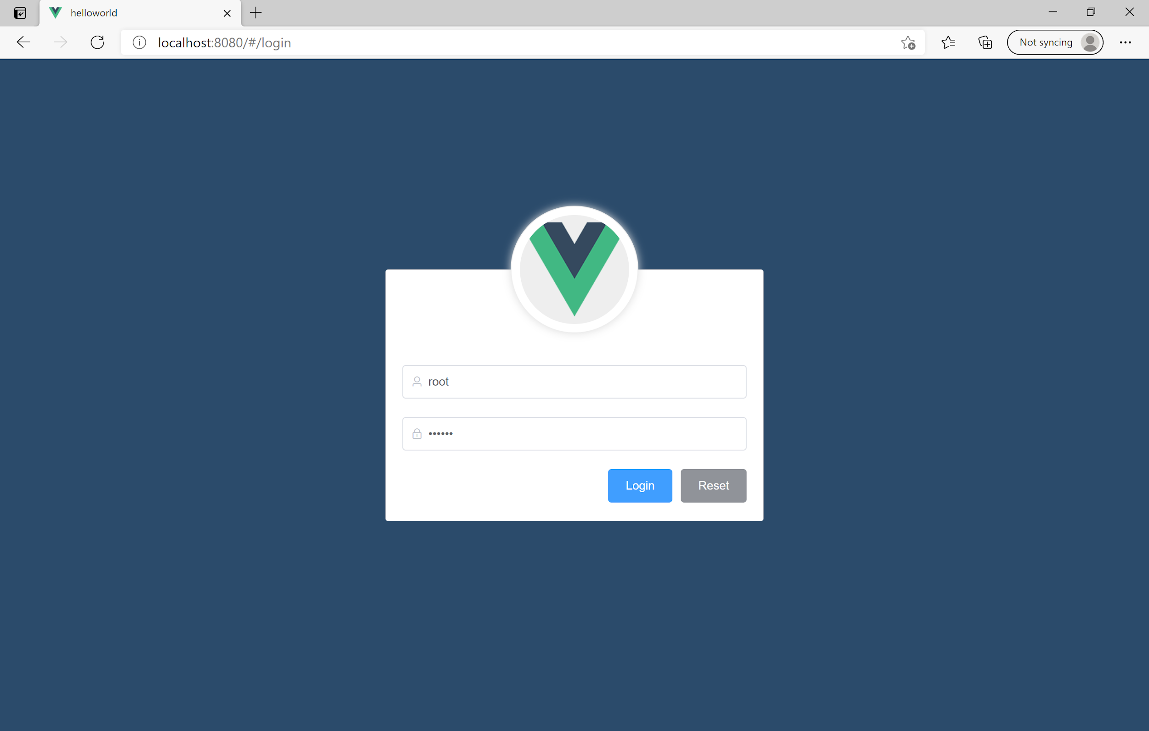

#### 3.0.2 Welcome Page

After successful login, administrators will be brought to the welcome page. The page consists of three parts: the header, aside, and the main content. Also, please notice that the token is stored in the session storage. So that the next time the administrator does not have to log in again. If the administrator wants to act more cautious, they can delete the token by **pressing** the **logout** **button** on the right top corner.

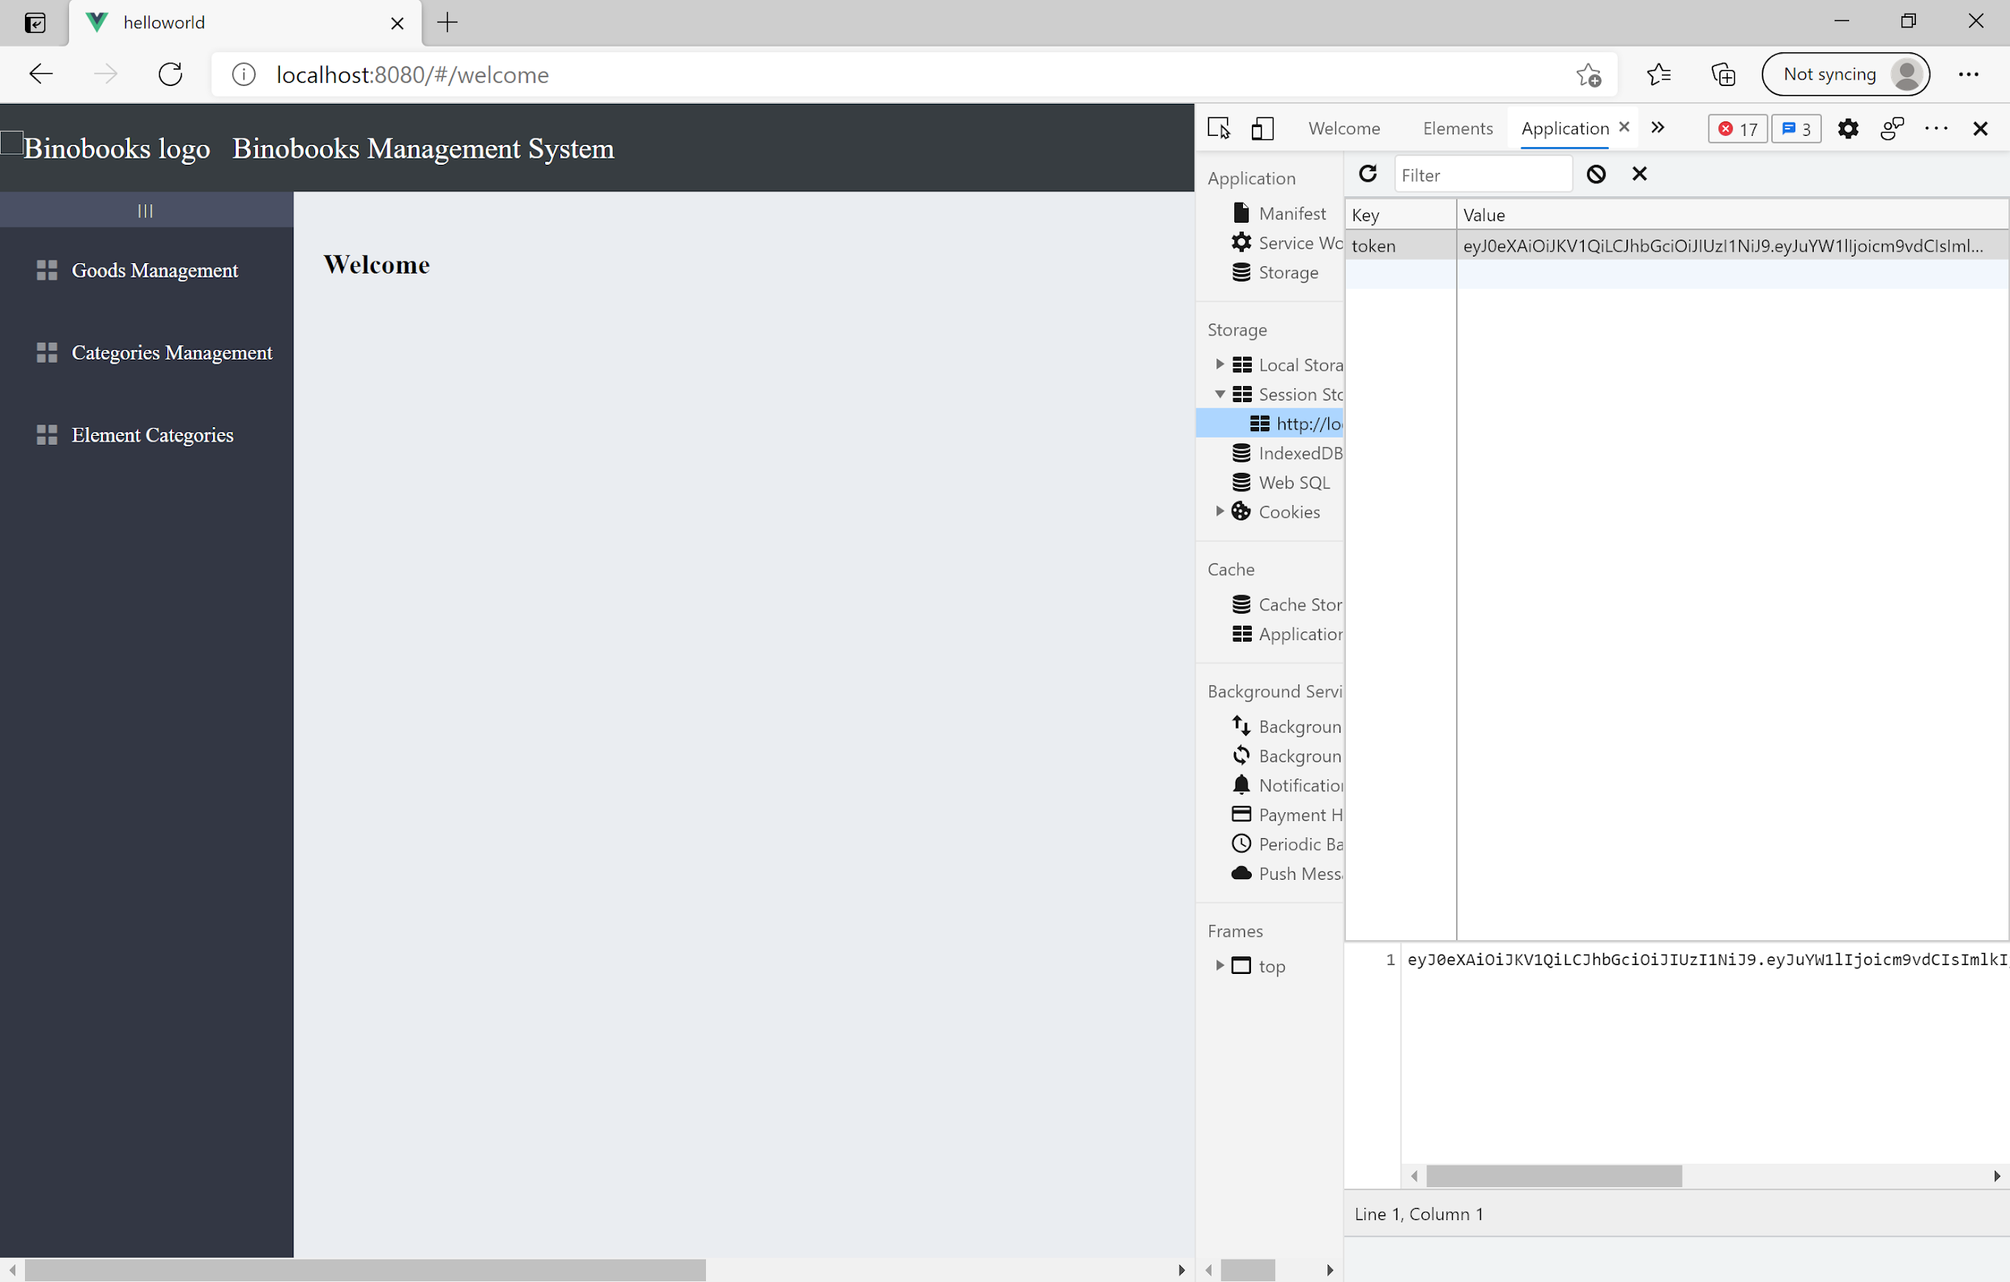

#### 3.0.3 Goods Management

For the goods management section, from the top to the bottom of the page, there are breadcrumb navigation, search bar, add book button, book table, and pagination.

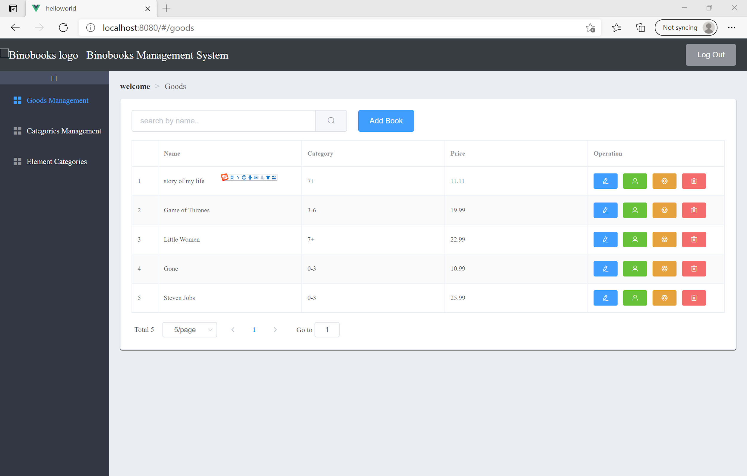

##### Add a Book

By pressing the **add** **book** button. A form will pop up, which contains all essential information regarding a book. By switching the **sale** button, administrators can easily decide whether to display the book on the website.

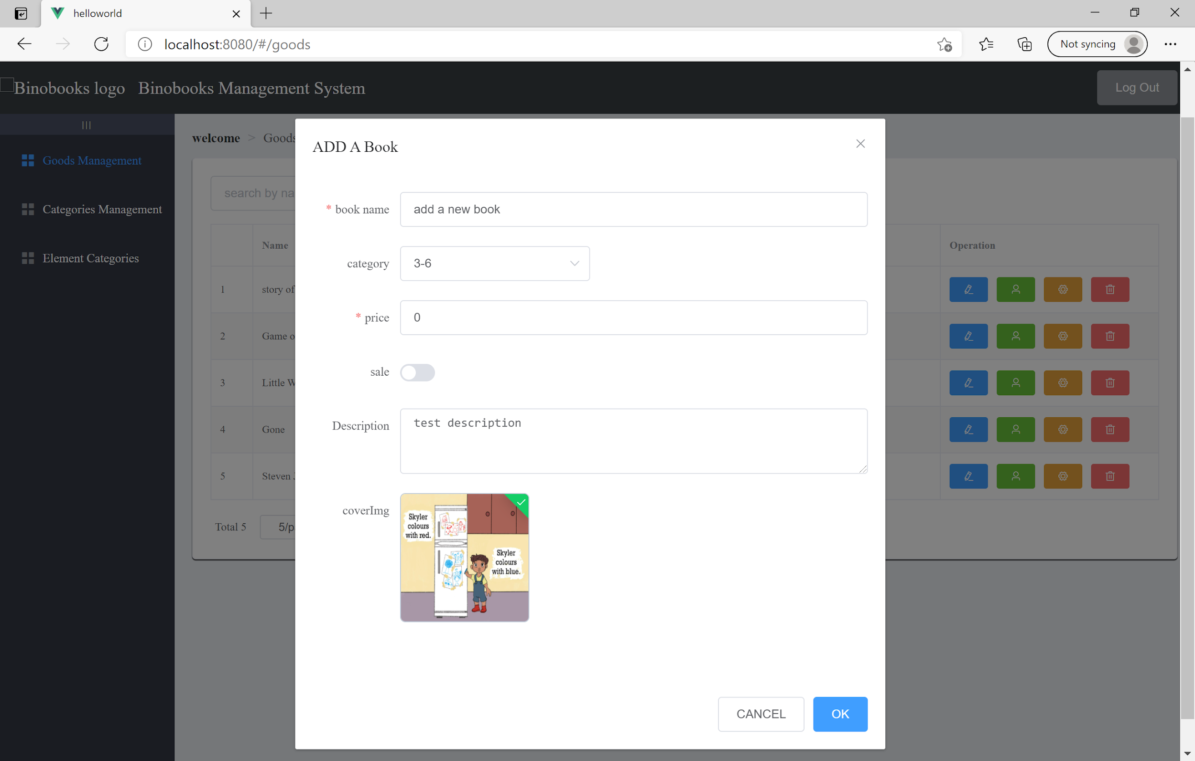

##### Pagination

We can view this book by either going to the next page or changing the **size per page**.

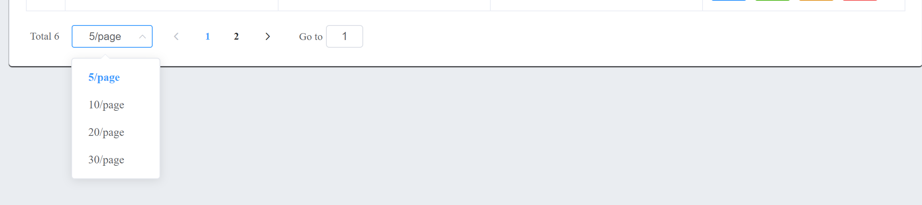

##### Modify a Book

Administrators may notice that the price of the new book is $0, so we can modify it by pressing the **blue button with the pen icon**. The same form will pop up again. You may notice that the picture cannot be displayed correctly. It relates to the bucket policy of MINIO.

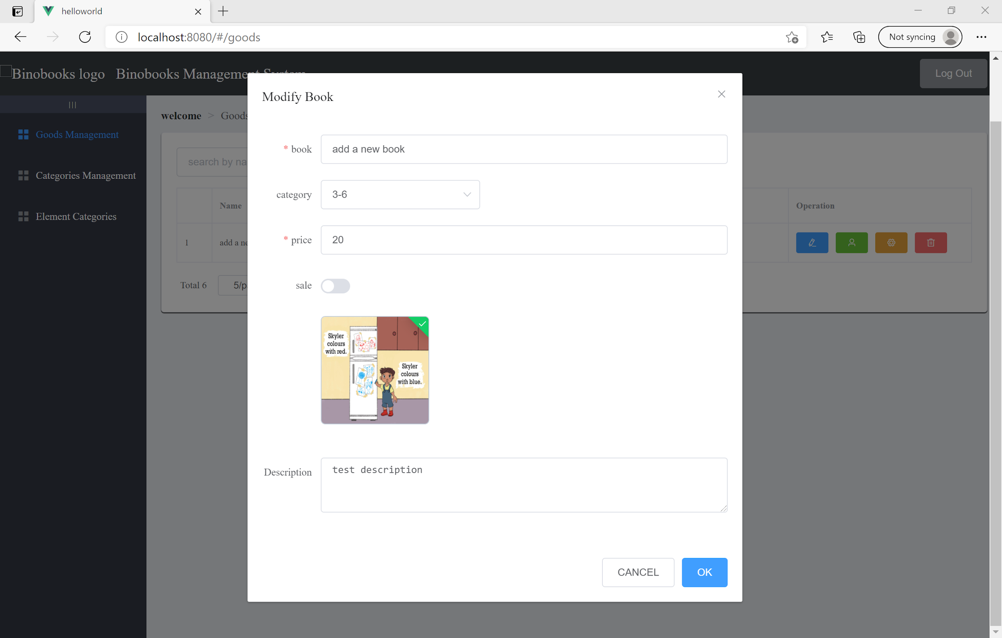

##### Modify a Book Element

Character is a critical part of the book, it needs to be set before we move on to the settings of customizable elements. By pressing the **green button with the user icon** we can enter the setting page. Then click the **Add** **an element** button, we can add a new row of an element.

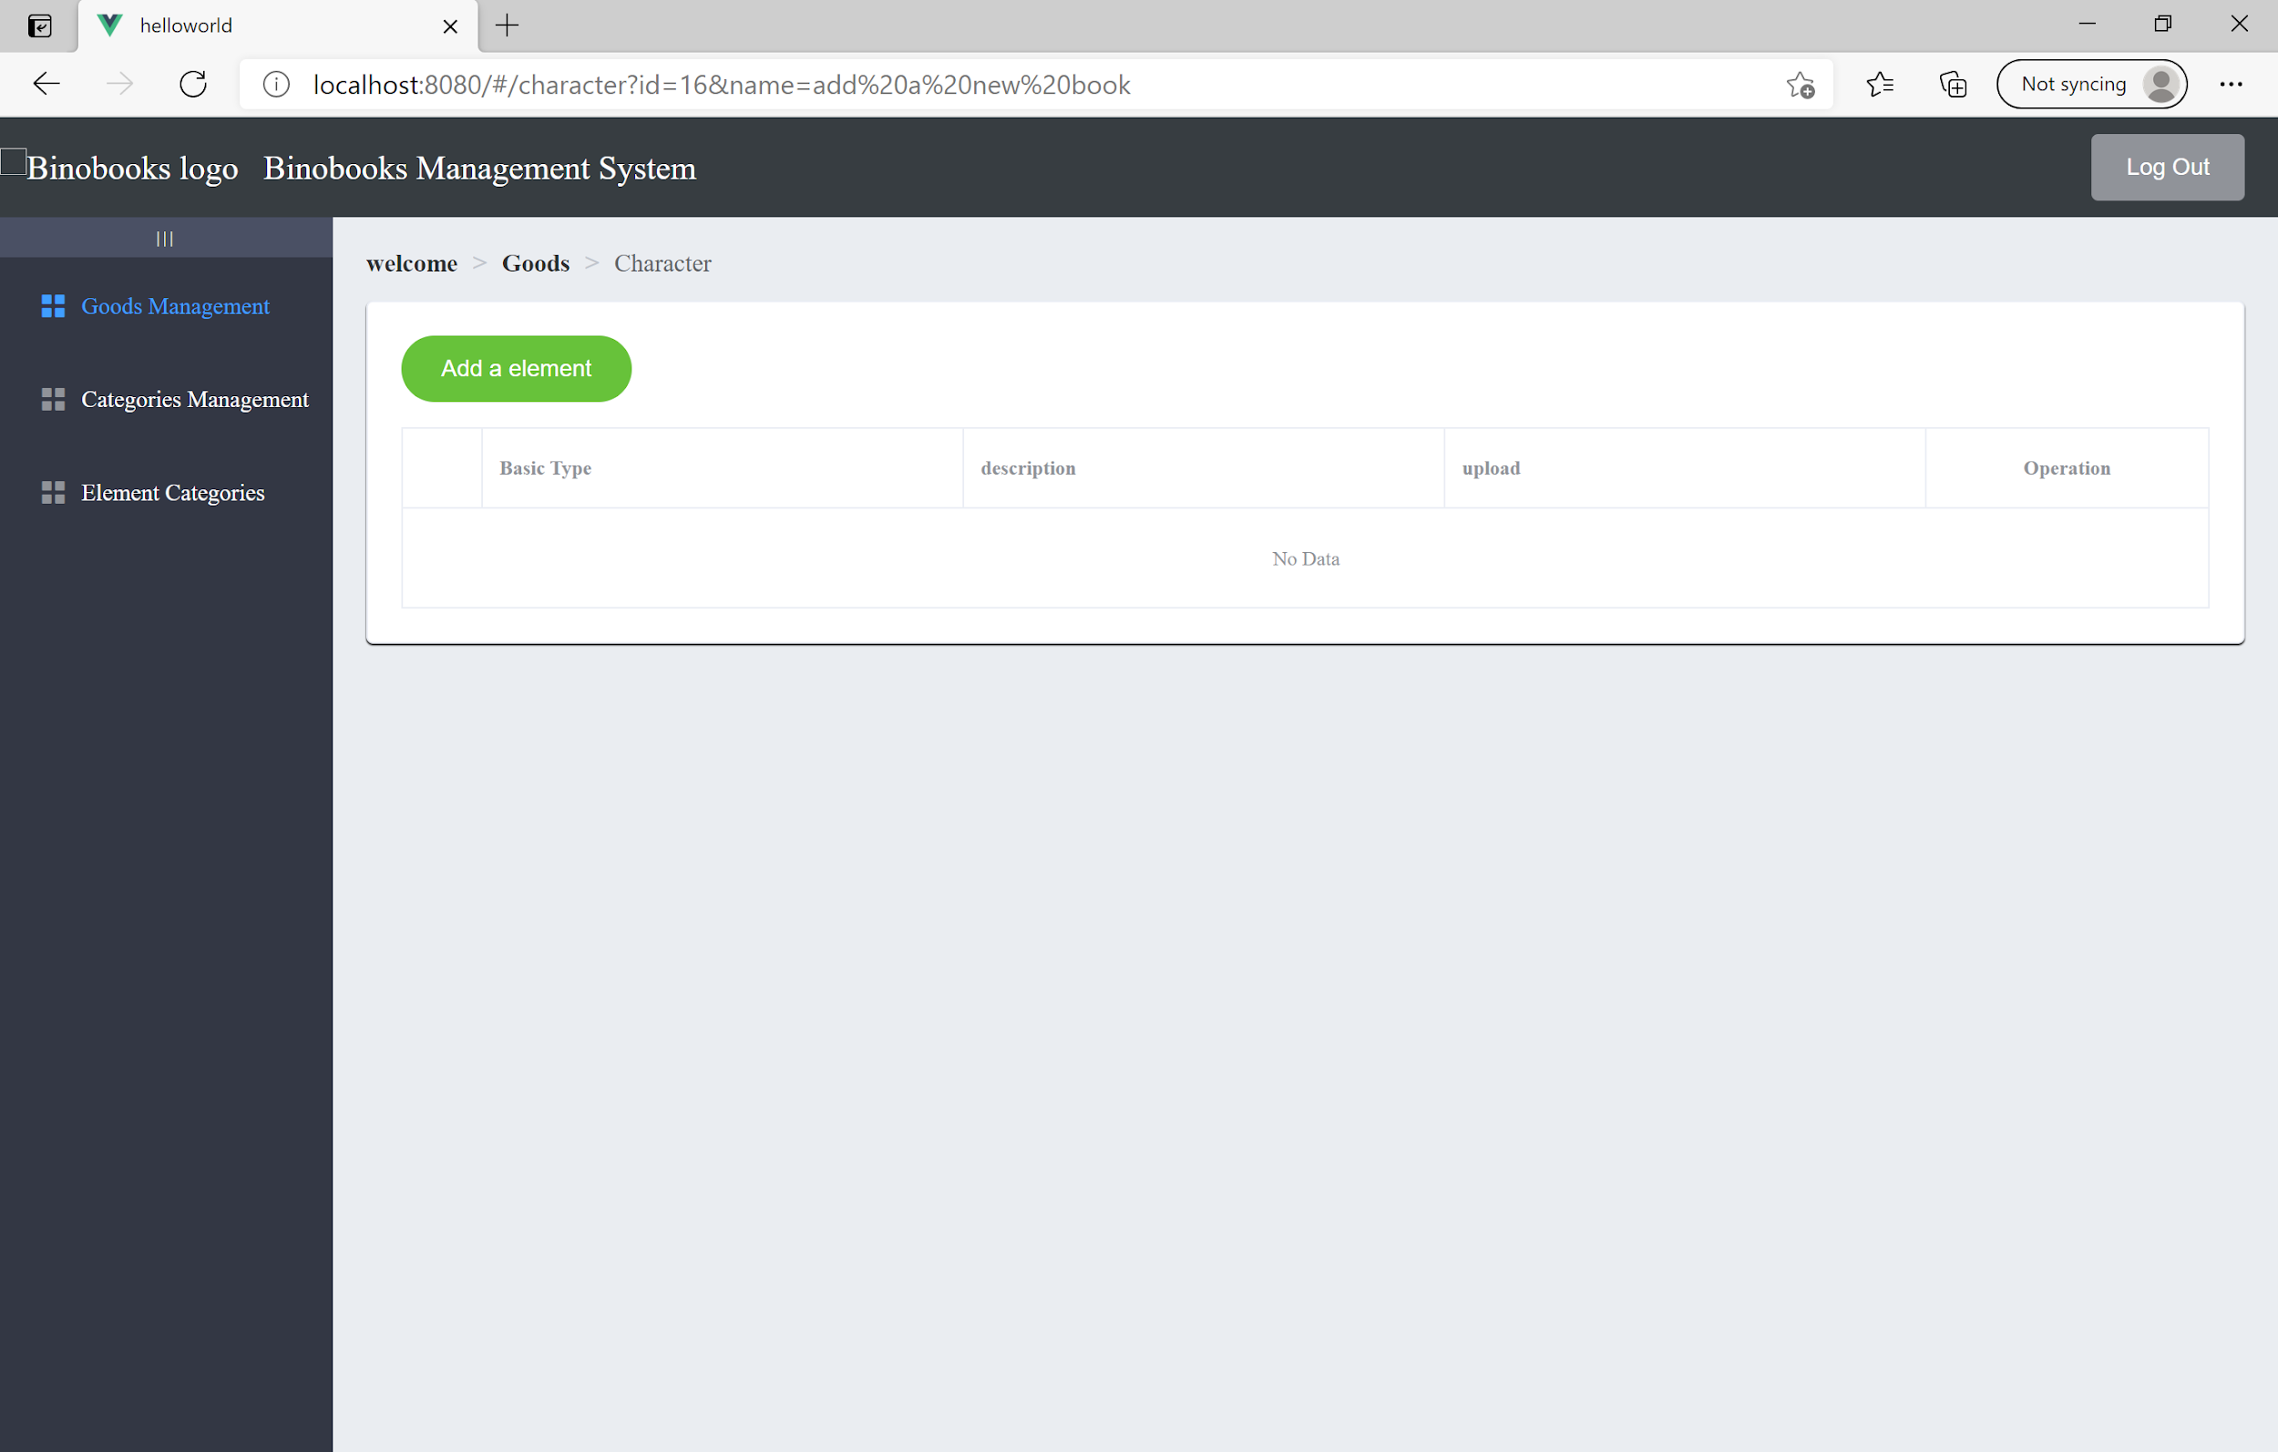

The basic type column corresponding to the element categories. The text in the description column will be used on the customer view page. The image is not necessary, but it enables the possibility of further development of character preview. When all the information is filled in, click the **blue button** and we can **save** it as well as update the row.

## 

Now we can see the new character element is uploaded successfully and shown in the column.

## 

##### Set Book Content

Now, we can back to the goods table and **click** to set the content of the book. It has identical structure except there is an expanded row that you can add customizable elements for each page. And notice that the type available is related to the element previously set in the character page. As for the customizable text, because of the restriction of backend code, it does not support newline. So, if you want to put text one on the top of another, you have to treat it as two elements and adjust the position correspondingly. For customizable text content, please use Placeholder.

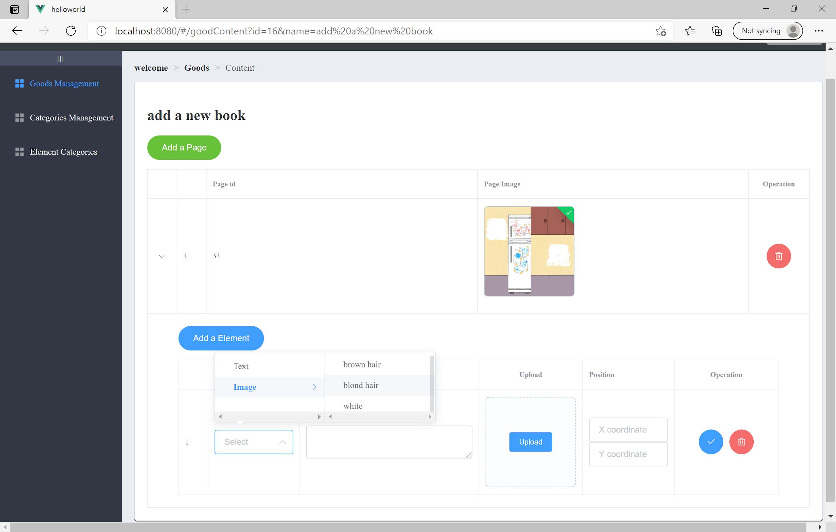

## 

#### 3.0.4 Category Management

Now, we move on to the categories management page. It has an identical structure to any other pages. Administrators can add, update and delete book categories here.

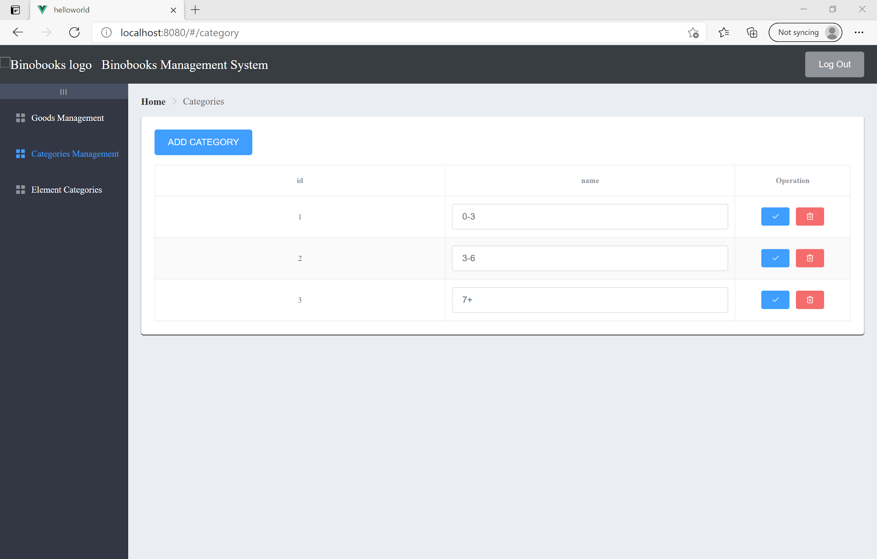

##### Modify Element Category

Moving on to the element categories page. It has an identical structure to any other pages. Administrators can add, update and delete basic element categories here.

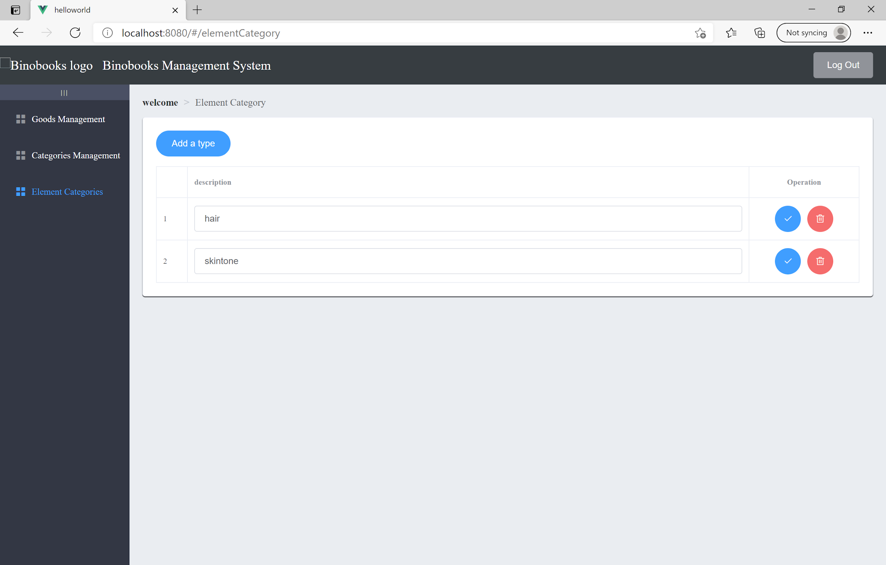

##### Delete Element Category

We designed to give administrators the maximum degree of freedom of the system. Administrators have the right to delete whatever they see in the system. When we implement the customization function, a lot of stuff is connected. Such as character reference to the basic element, and customizable images reference to the character. So when you want to delete something, give it a second thought. We also raise a warning when they want to process such “dangerous” operations.

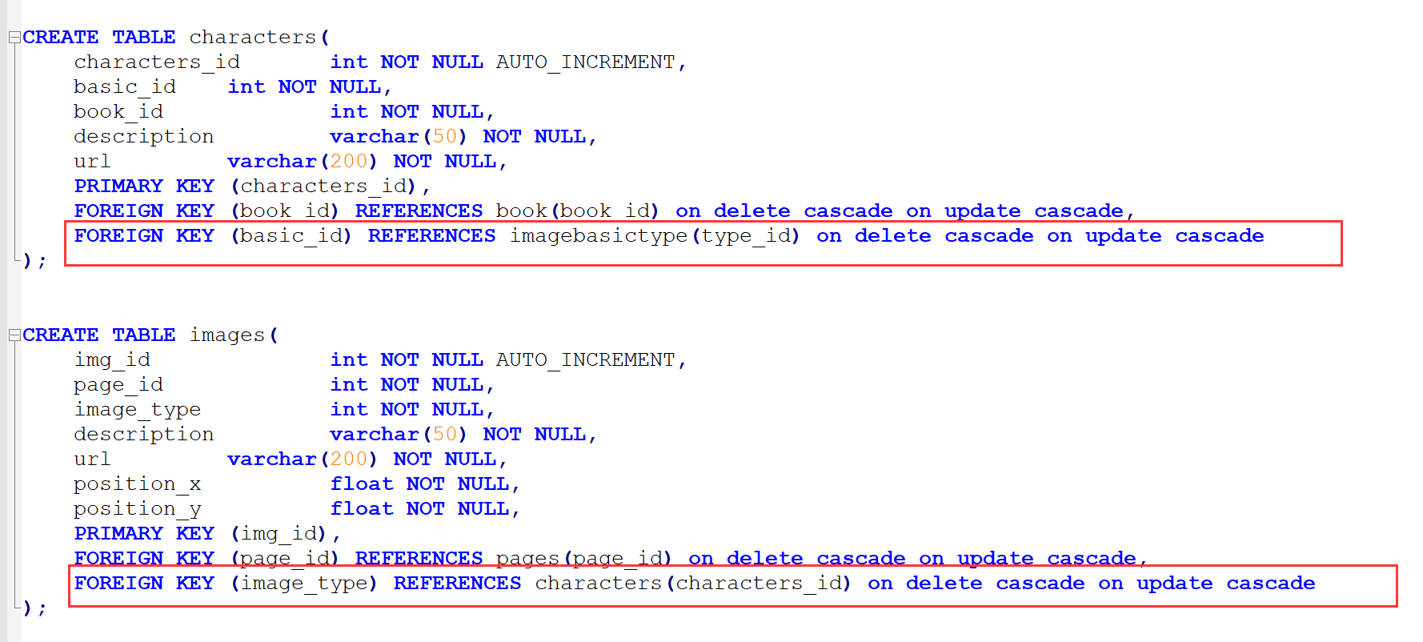

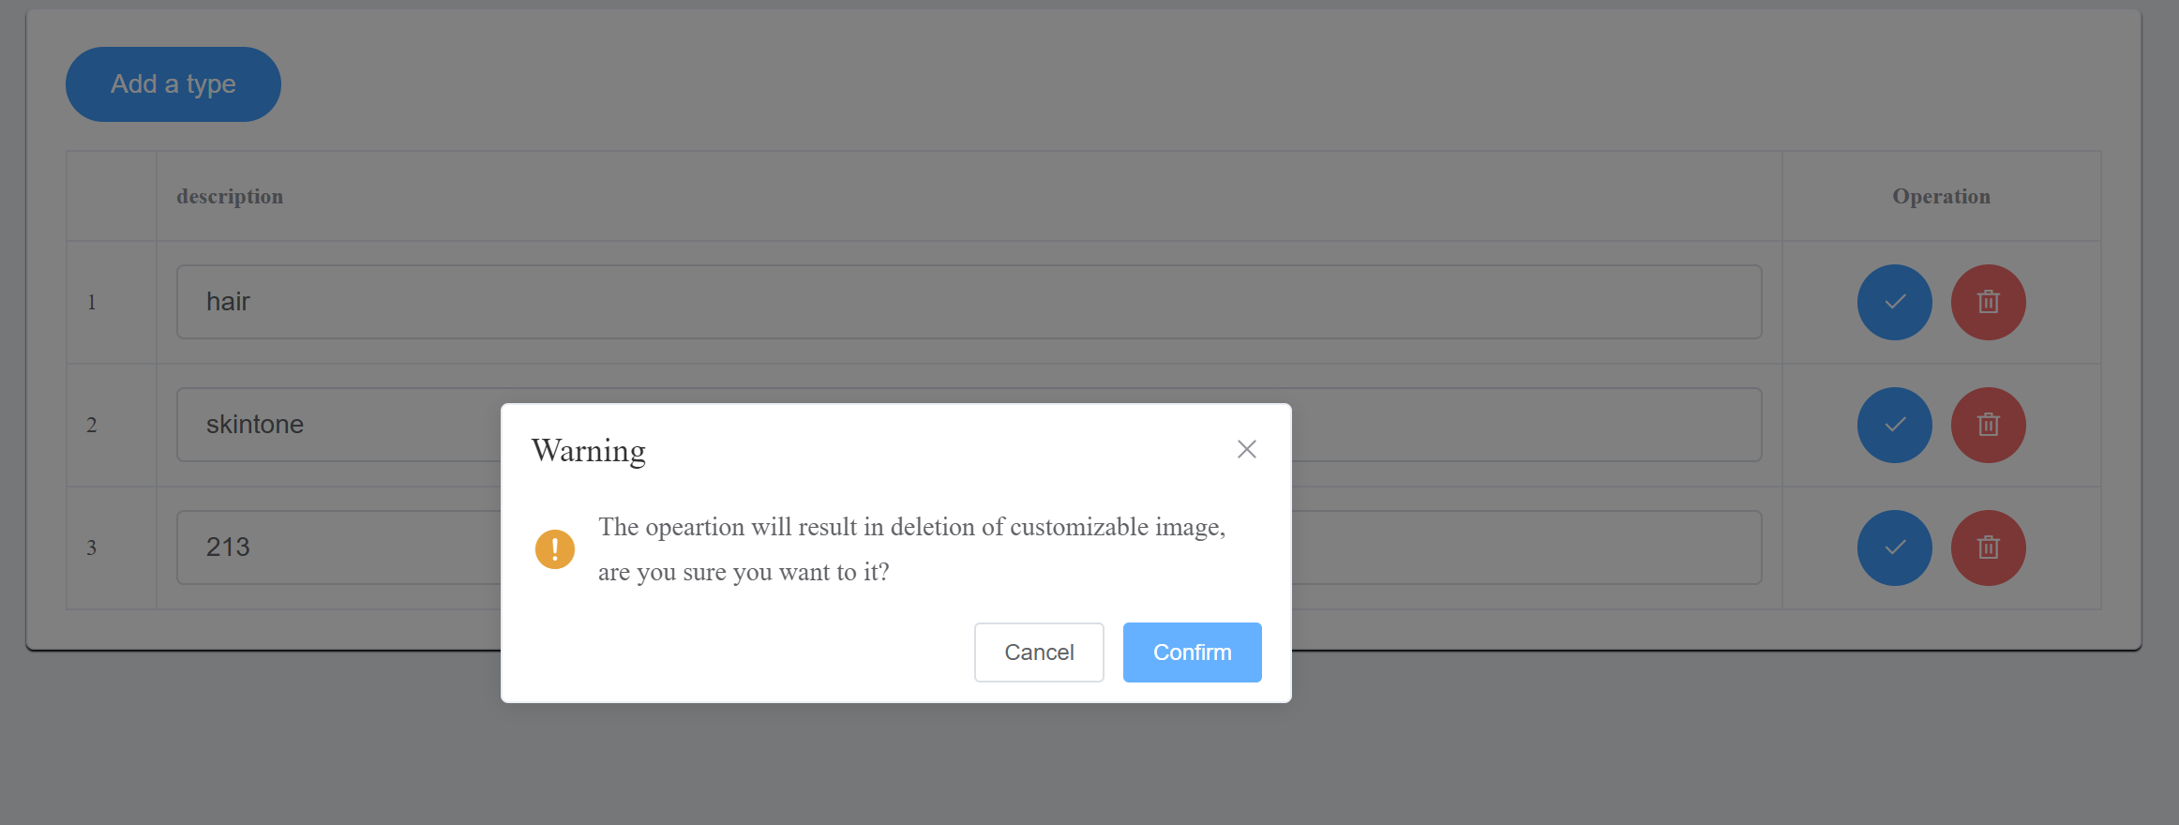

#### 3.0.5 Account management

Administrators can also have the rights of login and logout but they cannot register to become an administrator by self-registration. Only an existing administrator can create another administrator account.

An administrator can manage all customer information e.g update their accounts.

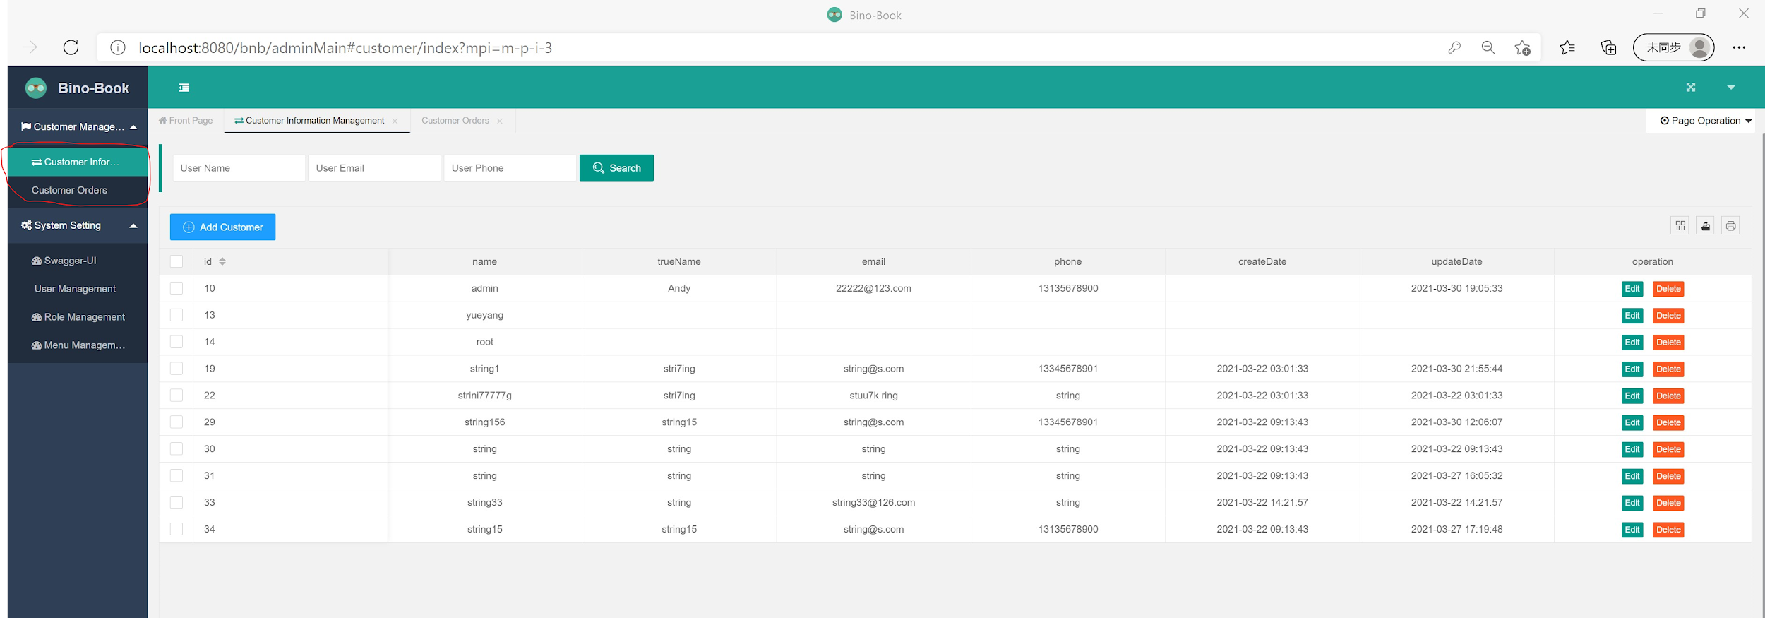

An administrator can manage customer orders.

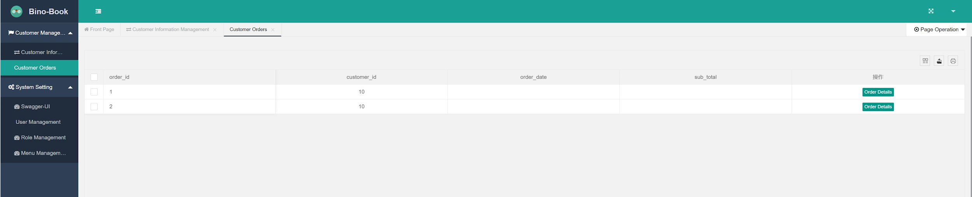

An administrator can manage other administrator’s account

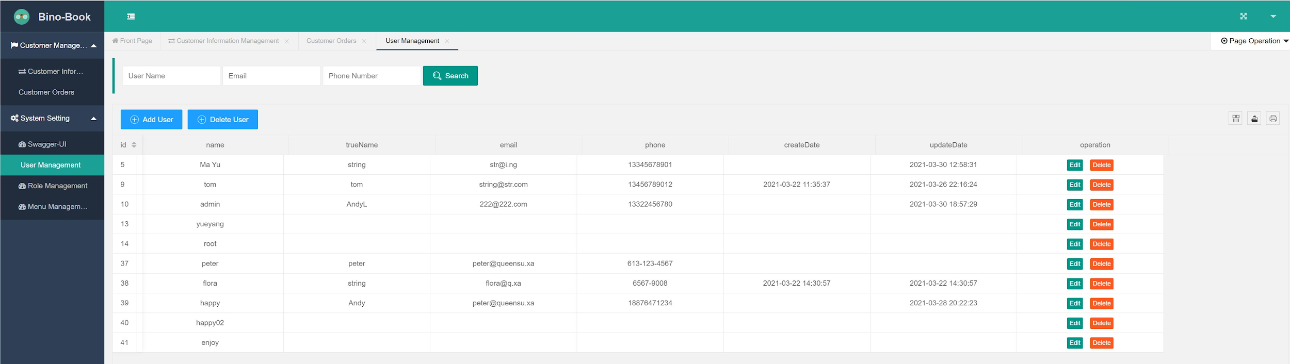

An administrator can grant permissions to an administrator account

If binobook Management wants to limit the privileges of more update other administrator’s accounts, a Role-Based-Access-Control (RBAC) mechanism should be introduced. We have tried to realize some parts of the RBAC mechanism as follows: For example, as a Human Resource Manager staff, he or she can view the backend staff management pages only. However, they cannot view the customer information and the swagger-ui information. As an IT manager, they can access the swagger-ui page only, and they cannot access the customer management and staff management pages. As a sales manager, they can only see the customer information page. We already realized such an authorization RBAC system, but it is still too simple, for example, we can only decide which manual can be accessed but we cannot control what kind of data should be authorized to them.

However, RBAC is not included in the contract so we just do some research on how to implement it. We also put this RBAC Authorization into the further development part.

### 4.0 Customer and Staff Management

#### 4.0.1 Customer Management

##### Register

Customers should input 3 information: **user name, user email, and user phone**. And no password is needed, and the system will give customers a default password of 123456 and prompt them to change their password as soon as possible.

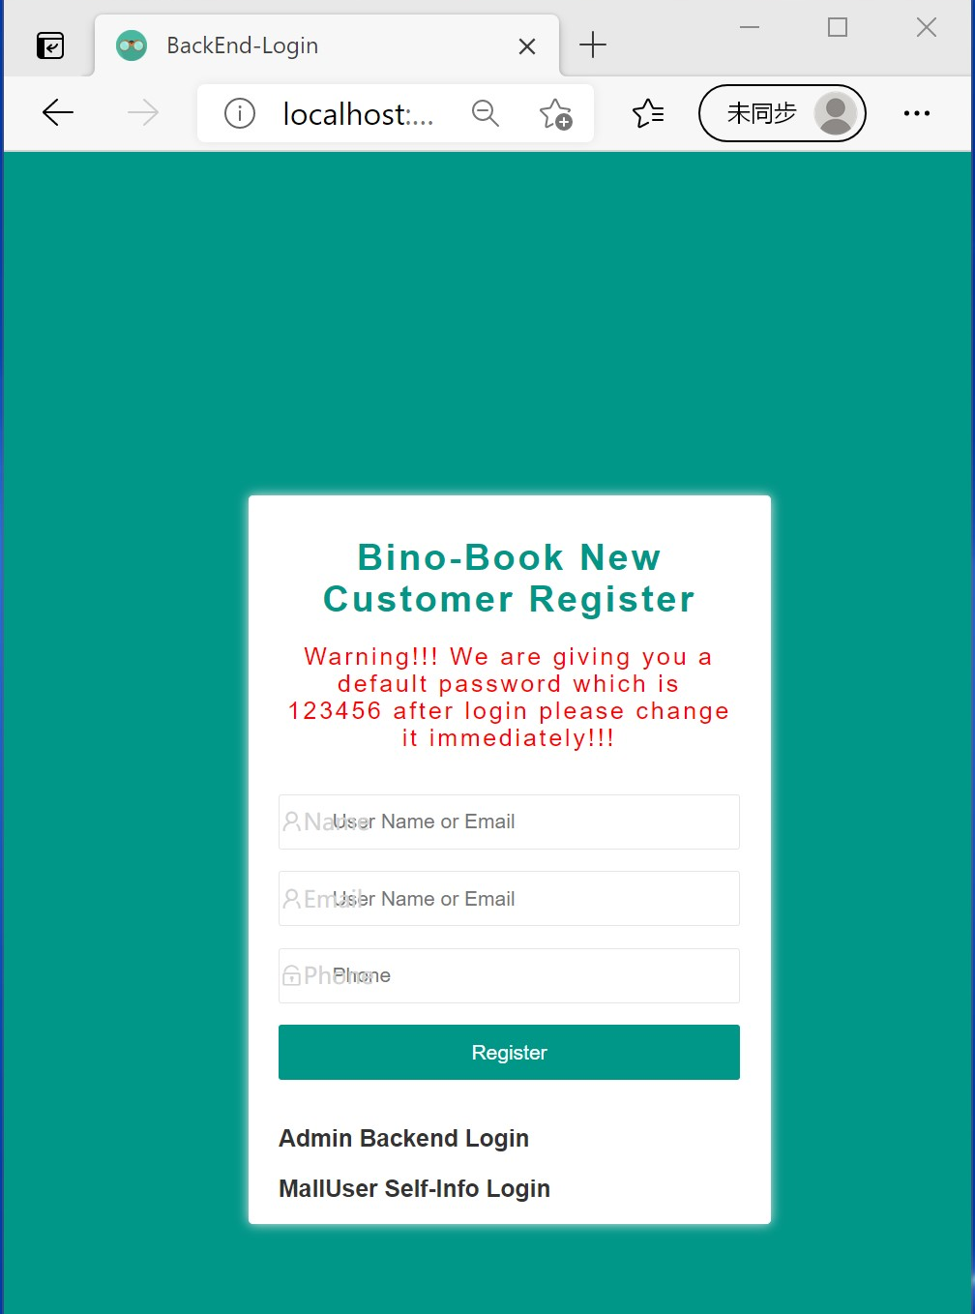

##### Login

Customers can login to the backend stage to view their personal information and the frontend to view their personal information and their orders.

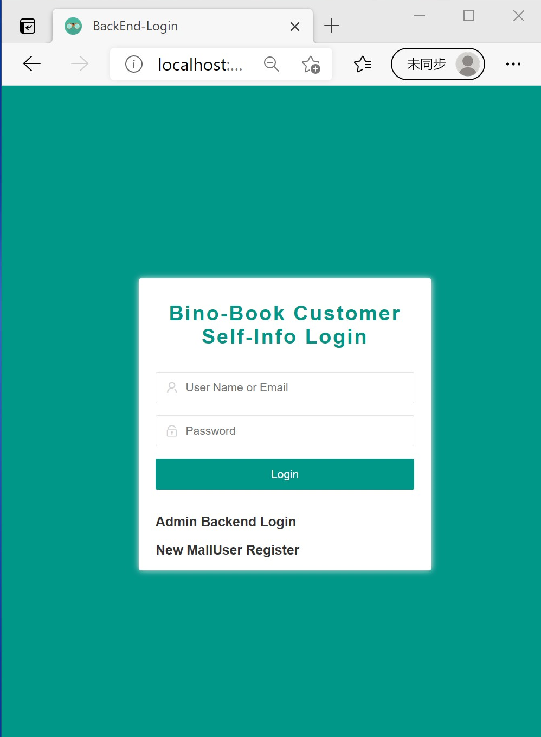

##### Manage User Information

Binobook Customer can update his or her password or user information.

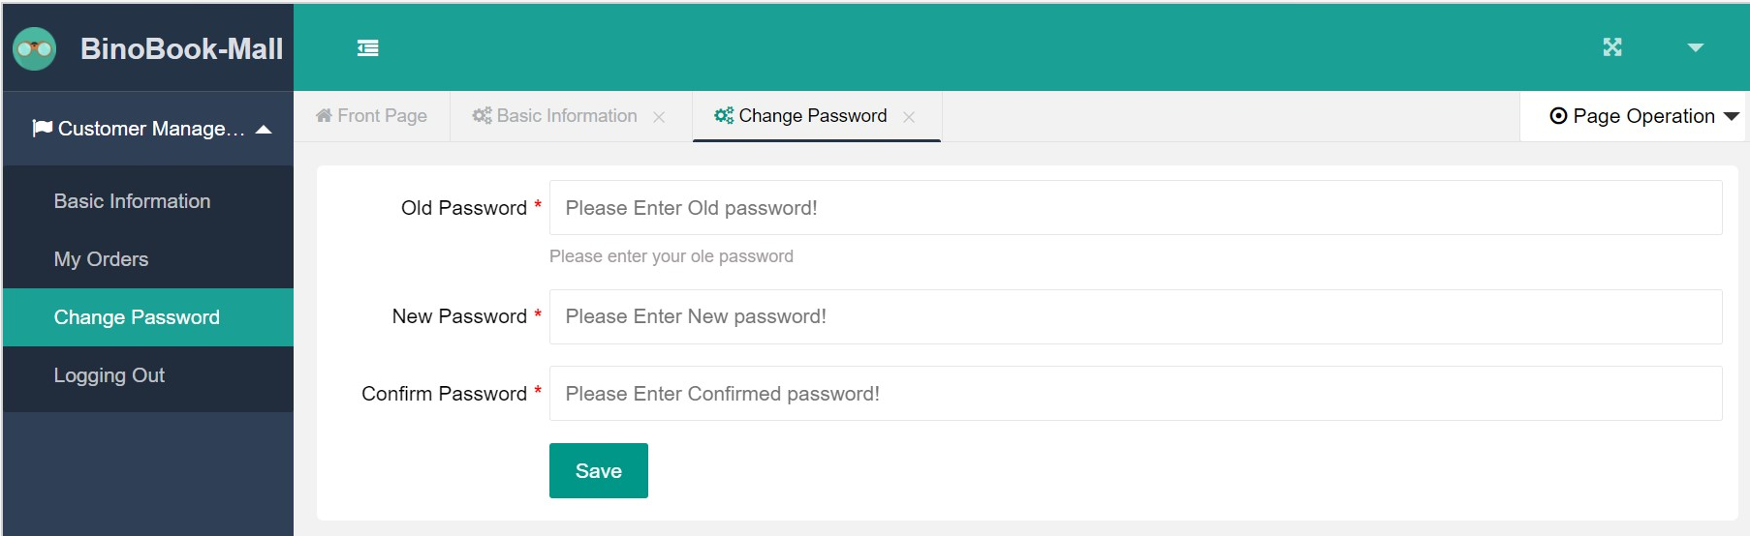

##### View an Order

Binobook Customer can view their orders in their account under **my orders** column.

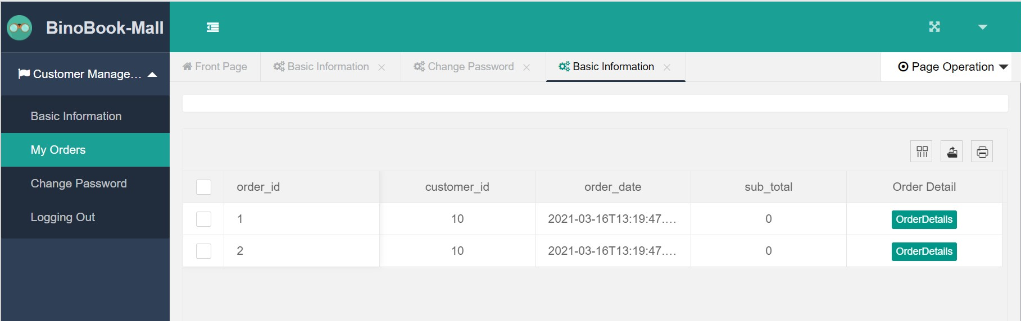

##### Logout

Customers can logout, and if they do not logout and the system will automatically logout if they do not type the keyboard within an hour. And we use sessions to control their rights of access.

### 5.0 File Management

#### 5.0.1 File Storage

MINIO is a light-weight file management system we use. Comparing storing files directly on the server disk, it provides a much more friendly GUI interface and as well as more built-in functions.

Web administrators can login with the correct access key and secret key to enter the platform.

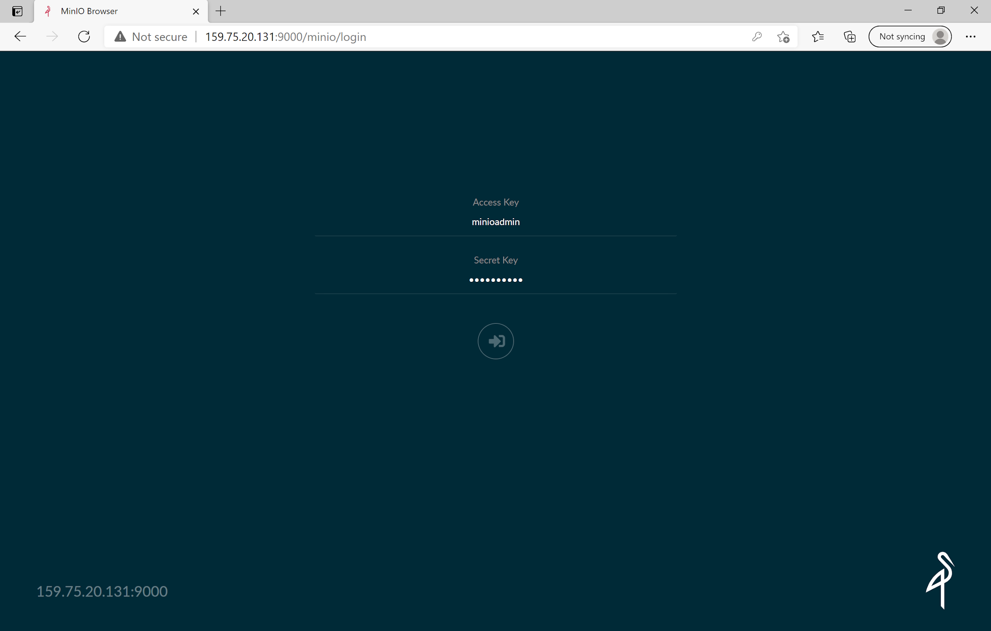

On the main page, the left side is a list of buckets. We treat each book as a bucket and in each book bucket, there are book cover folders, characters folders, and pages folders. So that everything is placed in order. Also, there are many folders in the customized and customized preview bucket to store the customer's built book in time order. So the owner can decide how long they want to keep these files.

## 

## Developer Maunal

### 1.0 Backend Service Overview

The backend is built on SpringBoot with MyBatis. There are 10 major entities i.e. Book, Category, User, Text, Character, Image, Image Basic Type, Image Extension Type, Image Full and Page. Detailed functionality classes are all implemented under the *controller* folder. The Book controller is used to manage the creation, delete, change and search functions of e-books. The Category controller is used to set the book category and the functions of search, delete an e-book with assigned book category. The User controller manages the authentication, creation, delete and update of a user. The Text controller manages the book contents like the character name or book name. The Character controller controls the character elements used with customization like hair element, face element, etc. The Image controller is used to manage the images involved in this website. This entity also divides into Image Basic Type, Image Extension Type and Full Image classes. Additionally, the Page controller is used to manage the web page and supports users to search a book with indicated pages.

Following tables show some of the major entities API.

|  |  |
| --- | --- |
| URL link | Description |
| /book/findAll/{page}/{size} | search books in pagination |
| /book/findById/{id} | find a book by book ID |
| /book/findByCateId/{id} | find a book by category ID |
| /book/findByName/{name} | find a book by relevant book name |
| /book/update | change a book contents |
| /book/save | create a new book |
| /book/deleteById/{id} | delete a book by book ID |

Book Class API

|  |  |
| --- | --- |
| URL link | Description |
| /character/all | find all the characters |
| /character/bookId/{id} | find a character by book ID |
| /character/update | change a book character |
| /character/save | create a new book character |
| /character/deleteById/{id} | delete a character by character ID |

Character Class API

|  |  |
| --- | --- |
| URL link | Description |
| /image/images/{id} | find one or several images by page ID |
| /image/update | change a image |
| /image/save | create a new image |
| /image/deleteById/{id} | delete a image by image ID |

Image Class API

To connect Java Object with MySQL database, we use MyBatis to write the associated SQL queries inside */resources/mappers* folder. We simply apply MVC architecture to design the whole backend. Java Objects and associated attributes are defined inside the *entity* folder, *dao* folder is used to map the Java Objects with the linked SQL queries. *Repository* folder is used to call the basic methods of defined Java Objects, then the *controller* folder includes the actual implementation of code of methods.

Binobook website also uses MINIO server to save images or the character elements used in book customization. Character elements used in each book are stored under the folder of the associated book-name. The *MinioController* implements the functions to create and delete the images from the MINIO server.

We also provide an interface for the backend system which is the “book management system”. This can only be used by web administrators to manage the books sold on the website and apply the book customization process manually. To run the backend server, goto */src/main/java/com.binobook/BackEndApplication.java* to run the whole backend.

### 1.1 Swagger-UI (Interactive API Document)

In addition, we also offer another option of swagger-ui to administrator users. Swagger-ui API documents can be integrated into backend user systems and we can set a Authorization code that allows only the IT managers to view the swagger-ui interface. Actually swagger-ui can be an interactive API document and can function as the best further development tool.

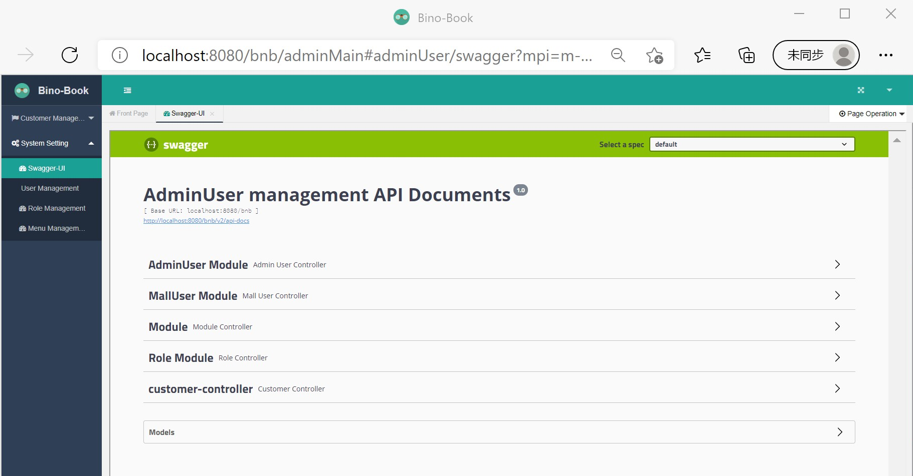

### 1.2 Book Customization

One of the main functions is to customize the book, it consists of about 150 lines of core code written in the *CustomizationController*. The idea is relatively easy, finding all images under the book and filter them by customer chosen character, put these images on the background image, and generate the PDF file. Two things can be further toned, one is in the *imageOverlpa* function. developers can change the order of drawing to generate different overlapping effects.



The other is in the *writeTextOnBackground* function, customers can change the font size and font style to generate different effects

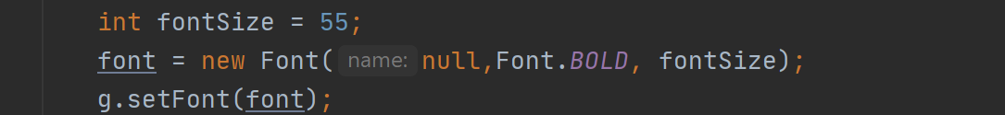

The upload function is as well as important, the function is implemented in the UploadRepositoryImpl. The core code is written as follows. All upload functions share the similar code.

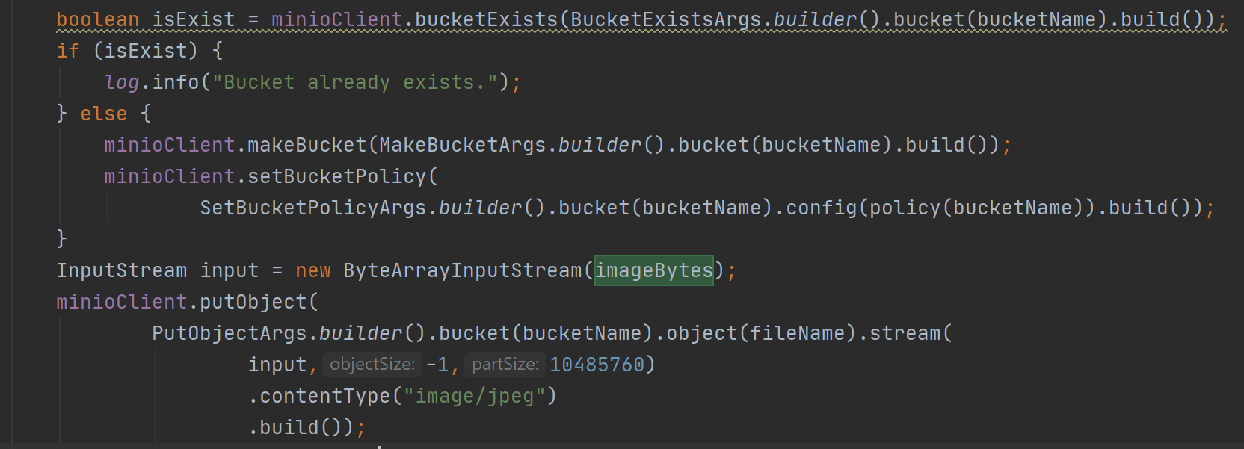

### 1.3 Book Preview

The function of preview can be found in *CustomizationController. W*e currently only provide one page for a preview. The owner can decide how many pages of previews are provided to customers.

### 

### 1.4 Security Control

#### 1.4.1 User Token

We use JWT and interceptors to generate tokens. JWT allows the server to recognize the user without storing anything on the server-side. The secret key, expiration time, and encode algorithm can be found in JWTUtils. The customer can modify it by themselves.

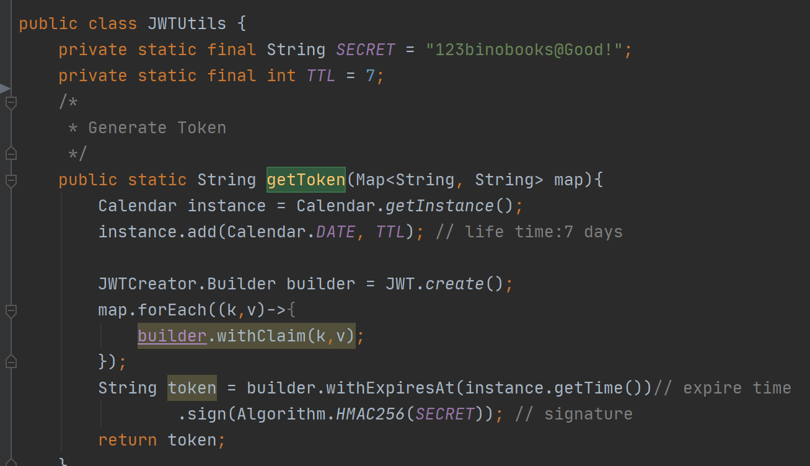

In the CrosConifg, we intercept any update, save and delete operations, and check if the sending request is with a token. When further developing new functionality, customers may want to temporarily disable it.

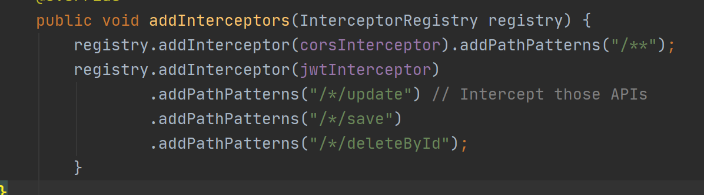

#### 1.4.2 Authentication

Authentication is the process of determining whether someone or something is, in fact, who or what it declares itself to be[1]. There are 3 most commonly used methods for authentication: Cookie, Session, and JWT.

Cookie: Easy to use and develop but the token is stored at the explorers on the customer side, therefore it is not so secure. Cookie is only valid in a request or response. And if a customer closes his explorer, cookies will expire. However, we can also make a setting saying that the cookie be stored for 7 or even longer days if the customer wishes. Customers do not need to repeat the authentication process(login) and the backend side can trace the behaviors of the customers. Therefore, the cookie is still the most widely used method of authentication.

Session: Session is stored at the backend. Therefore it is more secure than cookies. Cookie will only expire after a session is over or the server reloads.

Therefore, session is also a widely used method for authentication.

JWT: JSON web token (JWT), pronounced "jot", is an open standard (RFC 7519) that defines a compact and self-contained way for securely transmitting information between parties as a JSON object. Again, JWT is a standard, meaning that all JWTs are tokens, but not all tokens are JWTs.[2] JWT is believed to be a more secure authentication method. However, the token is stored in the customer side rather than the server side. It still has its limitations.

In our project, the mall system uses JWT and the customer and administrator management system use session.

#### 1.4.3 Authorization

Authorization is the function of specifying access rights/privileges to resources, which is related to general information security and computer security, and to access control in particular. More formally, "to authorize" is to define an access policy.We have 3 mechanisms to implement the authorization process the first is MVC, and the interceptor to complete the authorization is shown below:

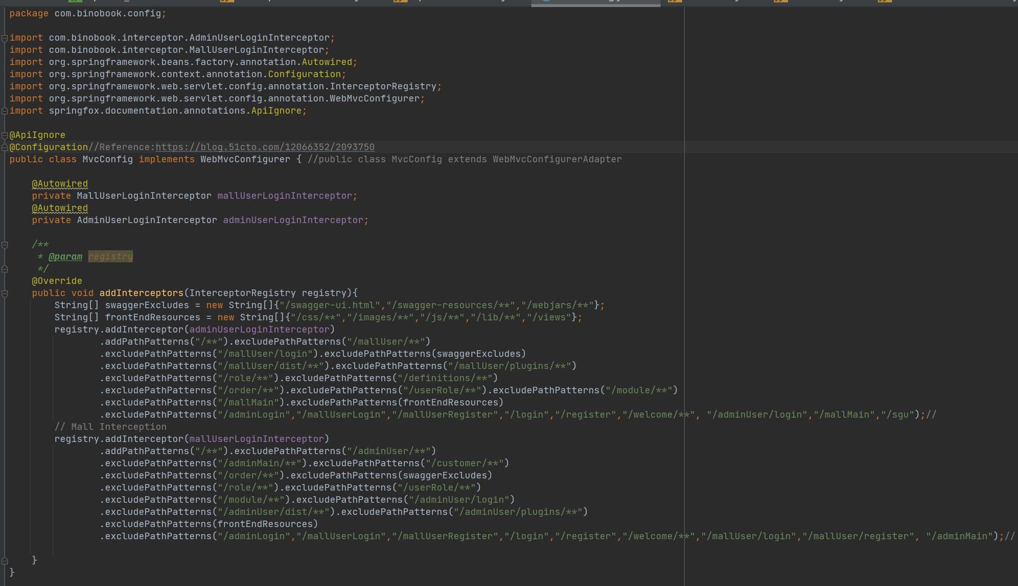

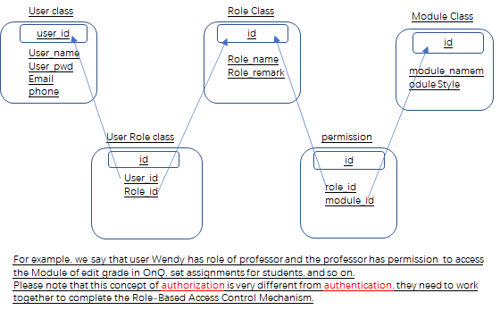

### 2.0 Frontend

#### 2.0.1 Project Structure

The frontend is built on Vue.js and Element UI and is differentiated by the customer-view pages and admin-view pages. Taking admin-view page for example, the structure is as below:

* The *assets* folder contains the global css and third party fonts.
* *components* folder consist of all pages and all kinds of event handler.
* *plugins/element.js* is the place where you should import any component from element UI
* *router/index.js* defines how page rout to the other pages.
* *App.vue* defines the entry of the project
* *main.js* specifies anything you want to do with the whole project, such as interceptors of requests and responses, the base url and etc.

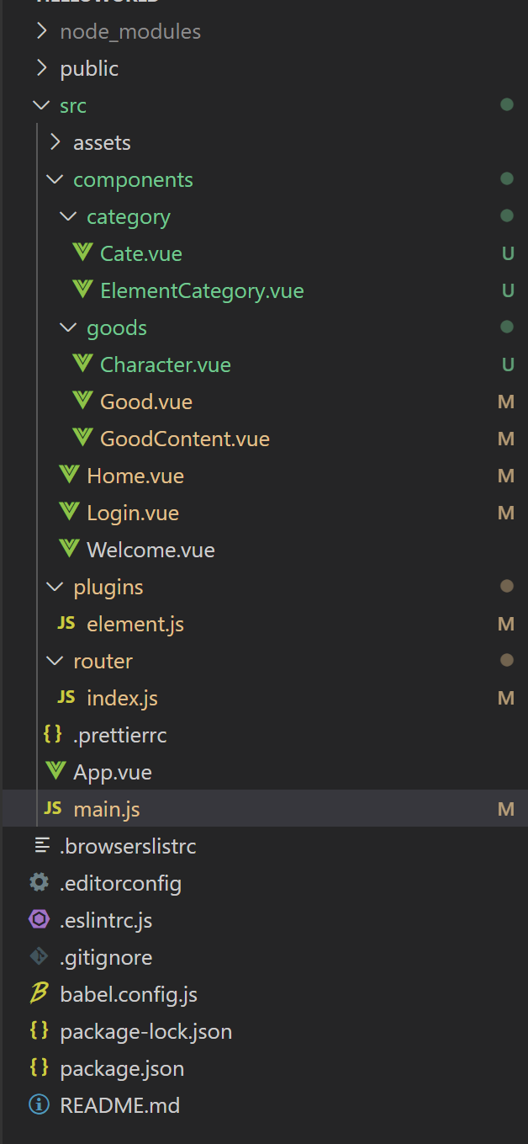

Figure Structure of Admin-view Frontend Project

#### 2.0.2 Import UI Elements

To compact the size of the project, all components in element UI are imported on-demand, which are all written in *plugins/element.js.*

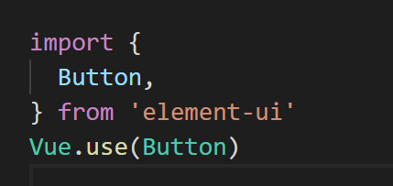

#### 2.0.3 Routing

Like many other commercial websites, we used dynamic routing (do not have to refresh to direct to the other pages). The routing rules are defined in the *router/index.js.*

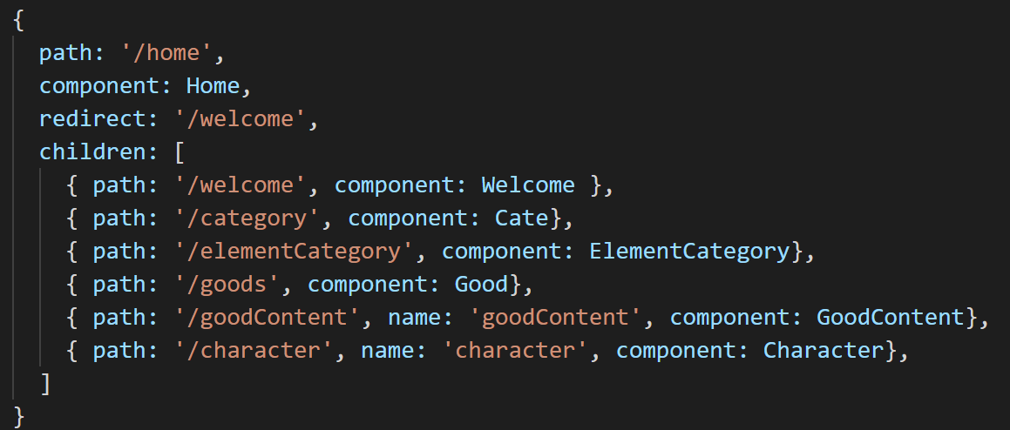

The entries of the routing are in both *App.vue* and *Home.vue,* which looks like this.

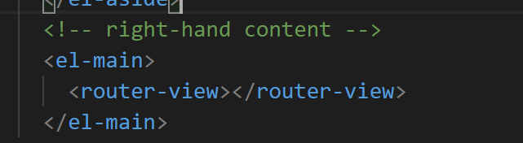

To protect from unauthorized access, we add a navigation guard in the *router/index.js* file. it will redirect you back to the login page till you successfully log in.

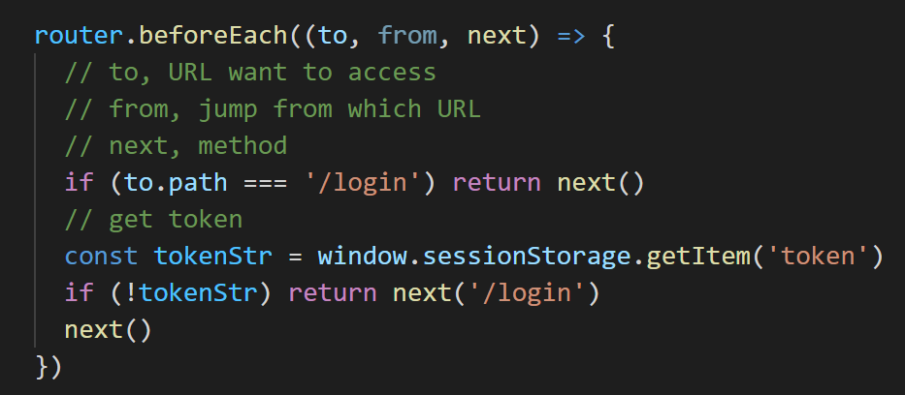

To utilize the JWT efficiently, we modify the request header before it is sent. So that the backend can retrieve the token from the header to verify it.

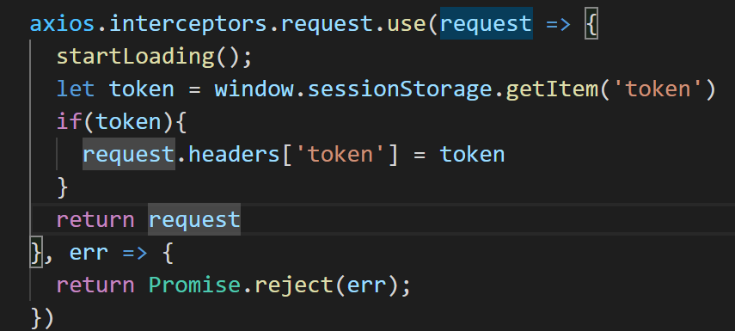

## Installation Guide

### 1.0 Environment Setup

##### Configure jdk1.8

1. download zip file [Linux x64 RPM Package](https://www.oracle.com/java/technologies/javase/javase-jdk8-downloads.html)
2. unzip the file and add variable to /etc/profile file

export JAVA_HOME=/home/jdk1.7/jdk1.7.0_80

export JRE_HOME=${JAVA_HOME}/jre

export CLASSPATH=.:${JAVA_HOME}/lib:${JRE_HOME}/lib

export PATH=${JAVA_HOME}/bin:$PATH

1. execute the environment

source /etc/profile

##### Configure tomcat 8.5.61

1. download the [zip file](https://tomcat.apache.org/download-80.cgi)
2. unzip the file and start up the server

cd /home/tomcat/apache-tomcat-8.5.61/bin

./startup.sh

##### Configure apache 2

apt-get install apache2

configure PHP

apt-get install php7

/etc/init.d/apache2 restart

##### Configure MySQL

1. Configure MySQL is relatively easy, can be all done through command line

sudo apt install mysql-server

sudo mysql

ALTER USER 'root'@'localhost' IDENTIFIED WITH mysql_native_password BY 'password';

FLUSH PRIVILEGES;

exit

##### Configure PhpMyAdmin

apt-get install phpmyadmin

sudo nano /etc/php/7.2/apache2/php.ini

uncomment extension=mysqli

sudo nano /etc/apache2/apache2.conf

add include /etc/phpmyadmin/apache.conf to the end of the file

/etc/init.d/apache2 restart

##### Configure MINIO

wget https://dl.min.io/server/minio/release/linux-amd64/minio

##### Configure the server firewall

1. open those ports which will be used

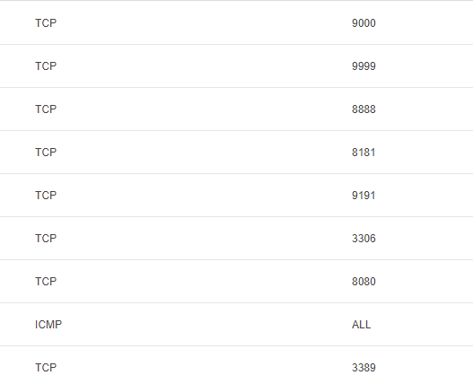

### 1.1 Build and Deployment

#### 1.1.1 Backend

##### Code Environment

We use IntelliJ IDEA to package our code. First go to the maven section on the right bar, under the lifecycle double click “package”. When build success information is printed out in the console, we shall find a package end with “.jar” under the target folder.

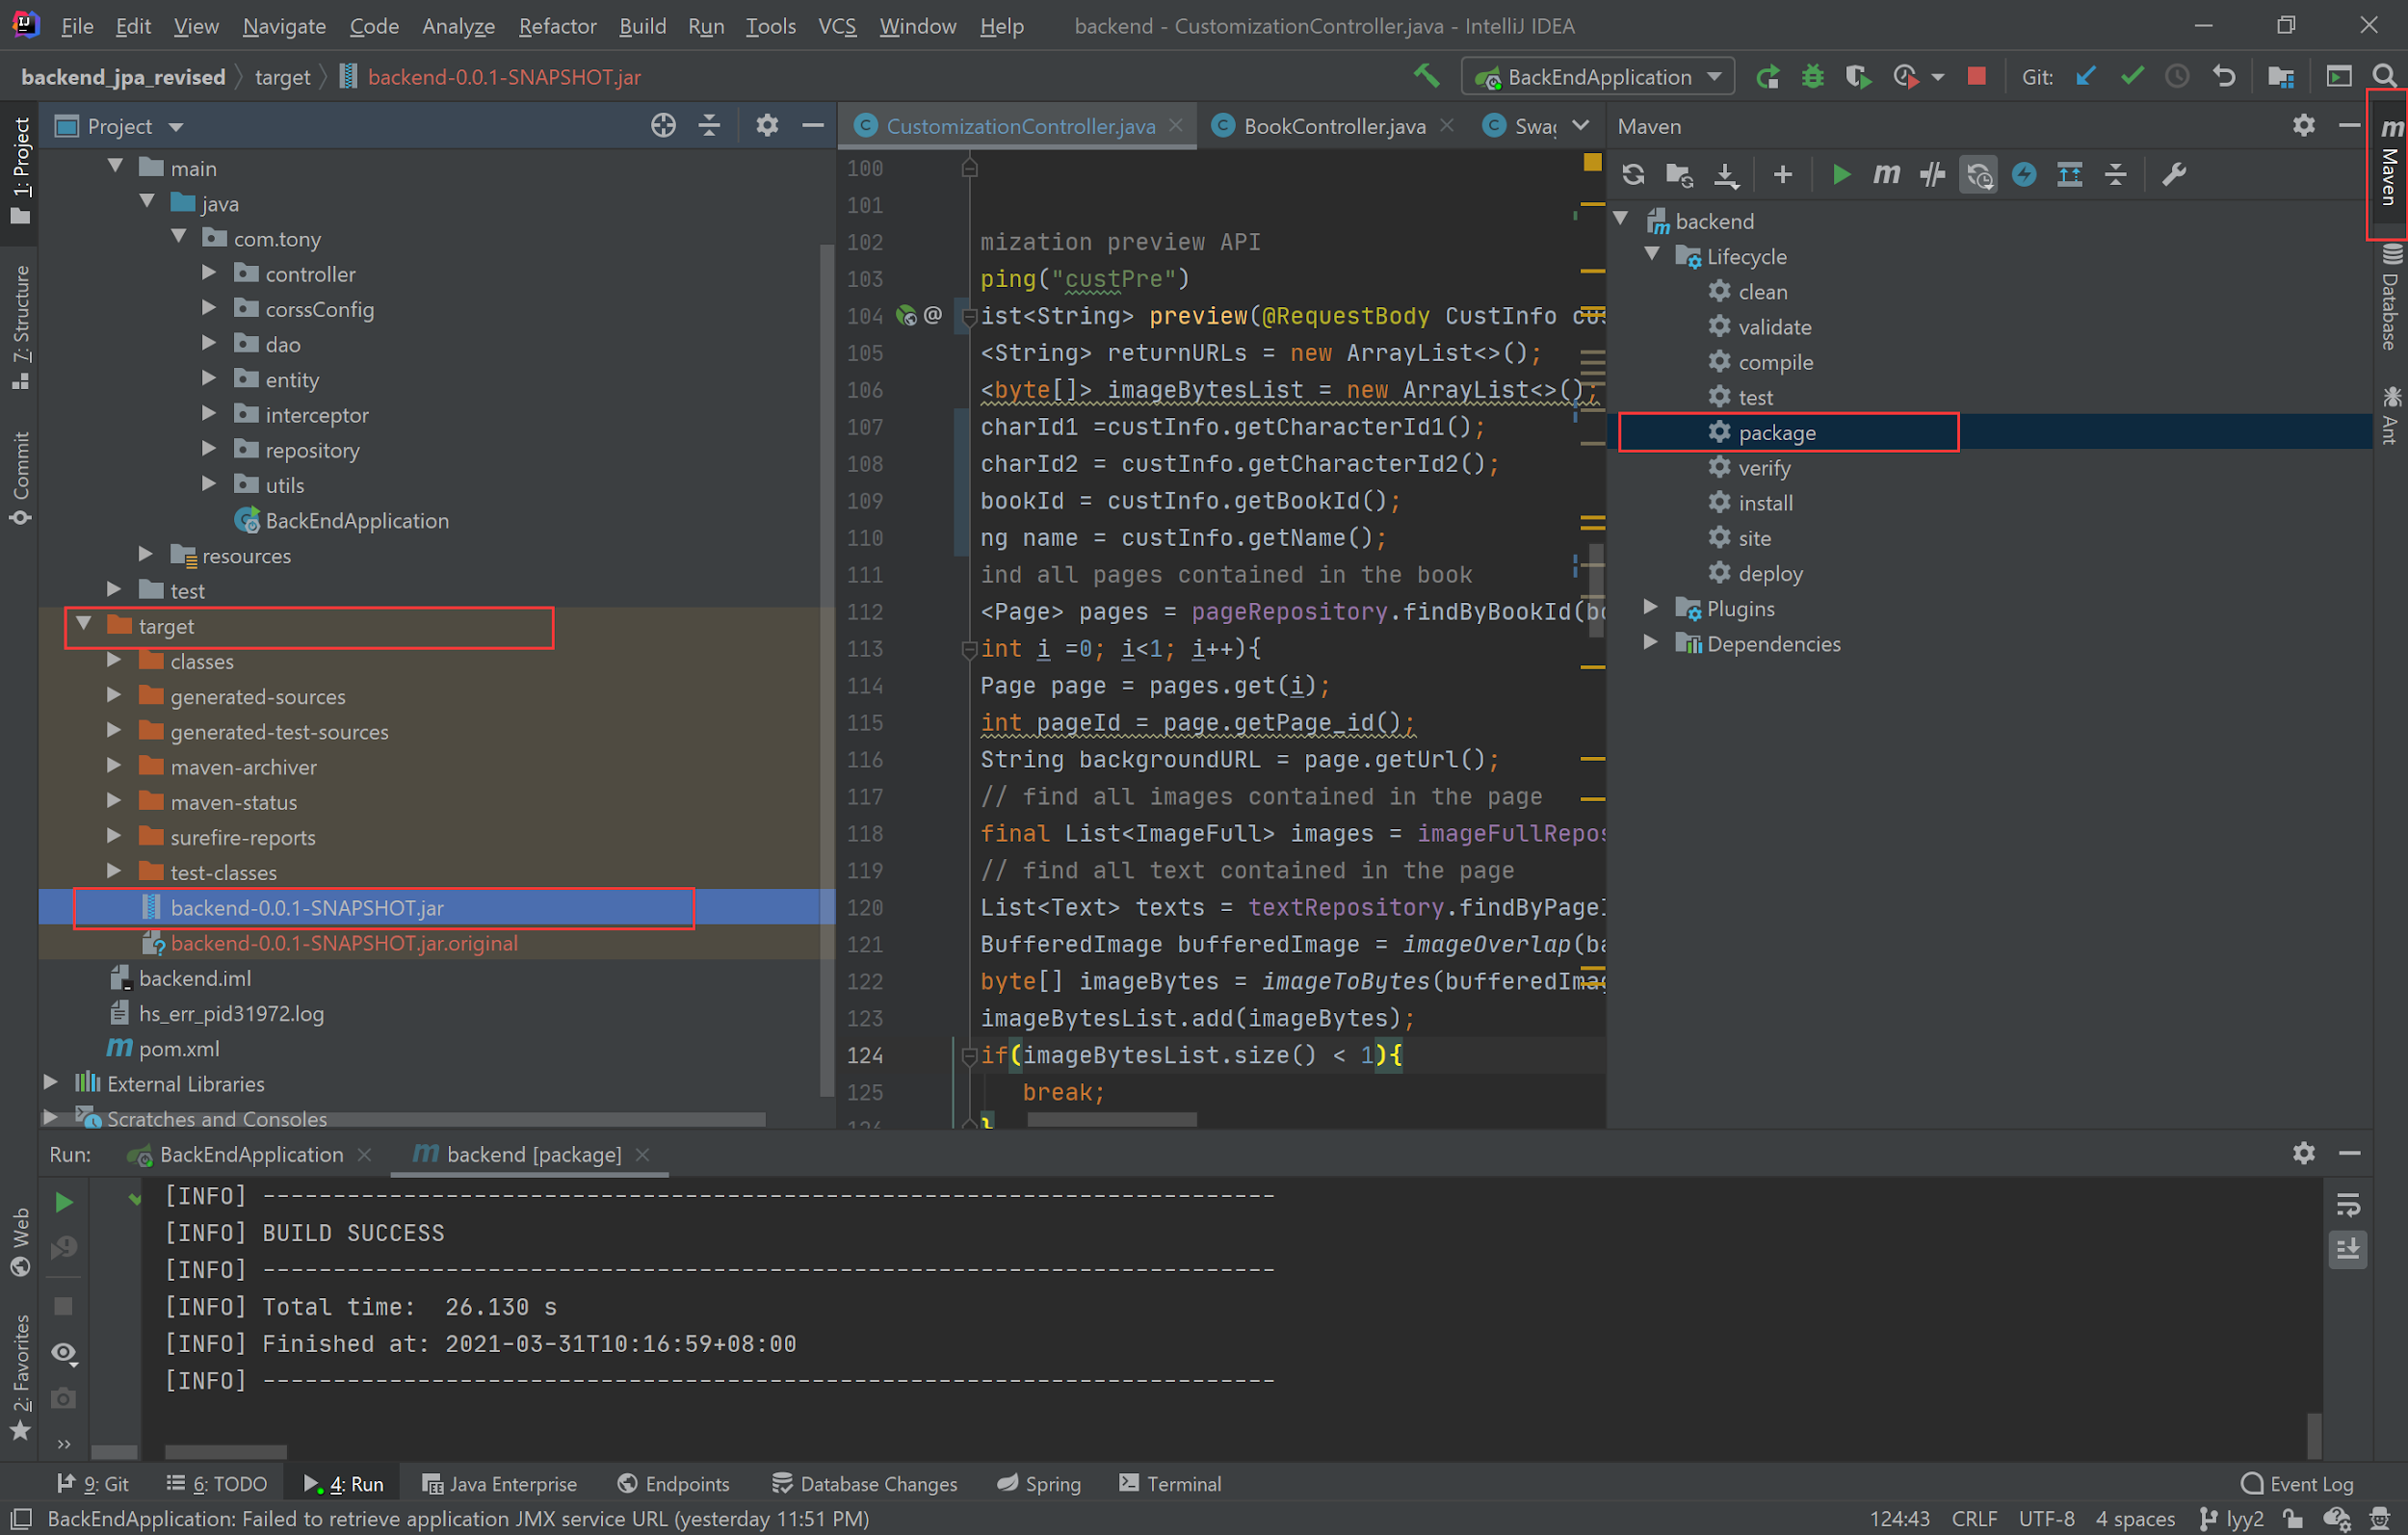

##### Server Setup

Use file transfer software to copy the jar package on the server with WinSCP. 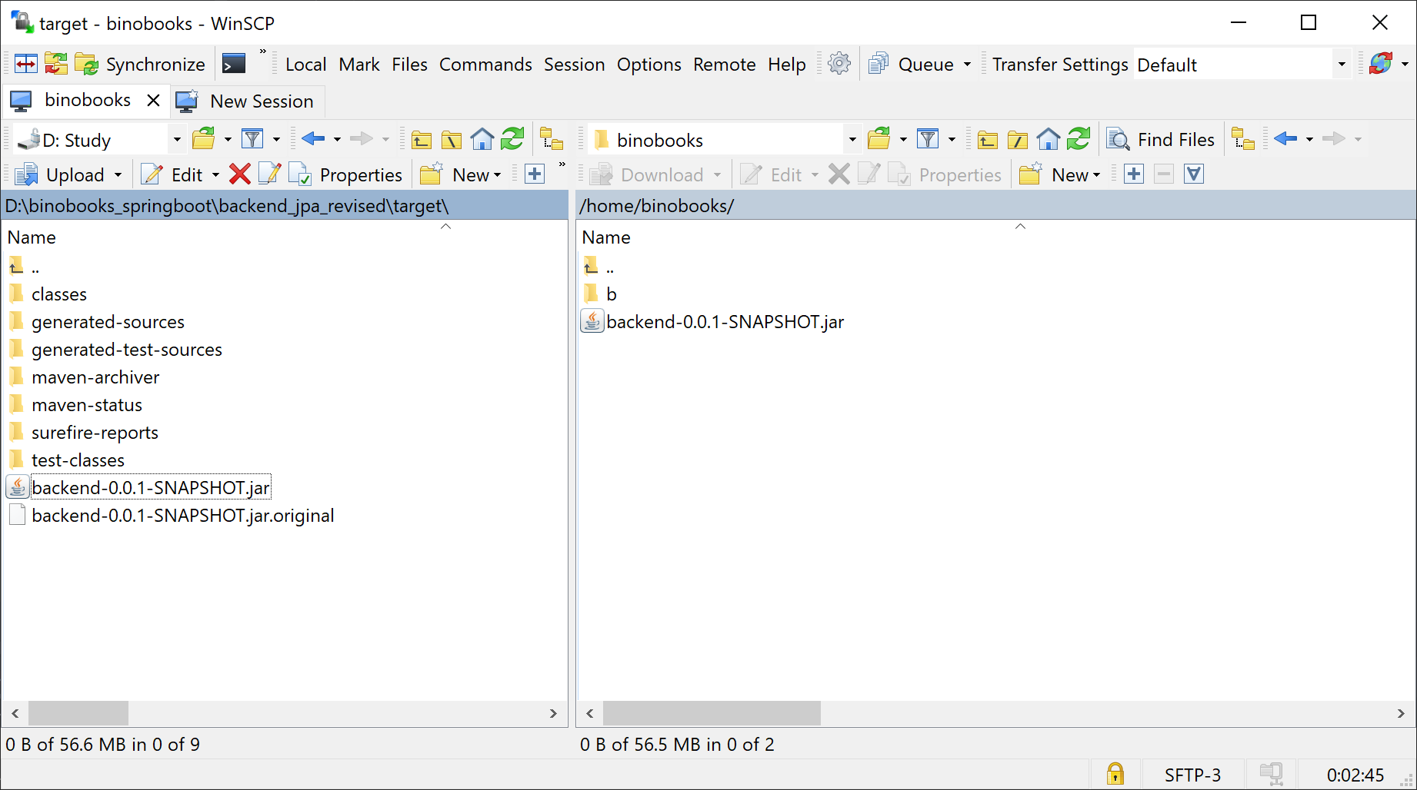

Now, we can go to the server terminal, and many cloud servers shall provide the entry. Then we enter the directory where we put the jar package. we can execute the package in the command window by typing:

nohup java -jar your-package-name.jar > log.file 2>&1 &

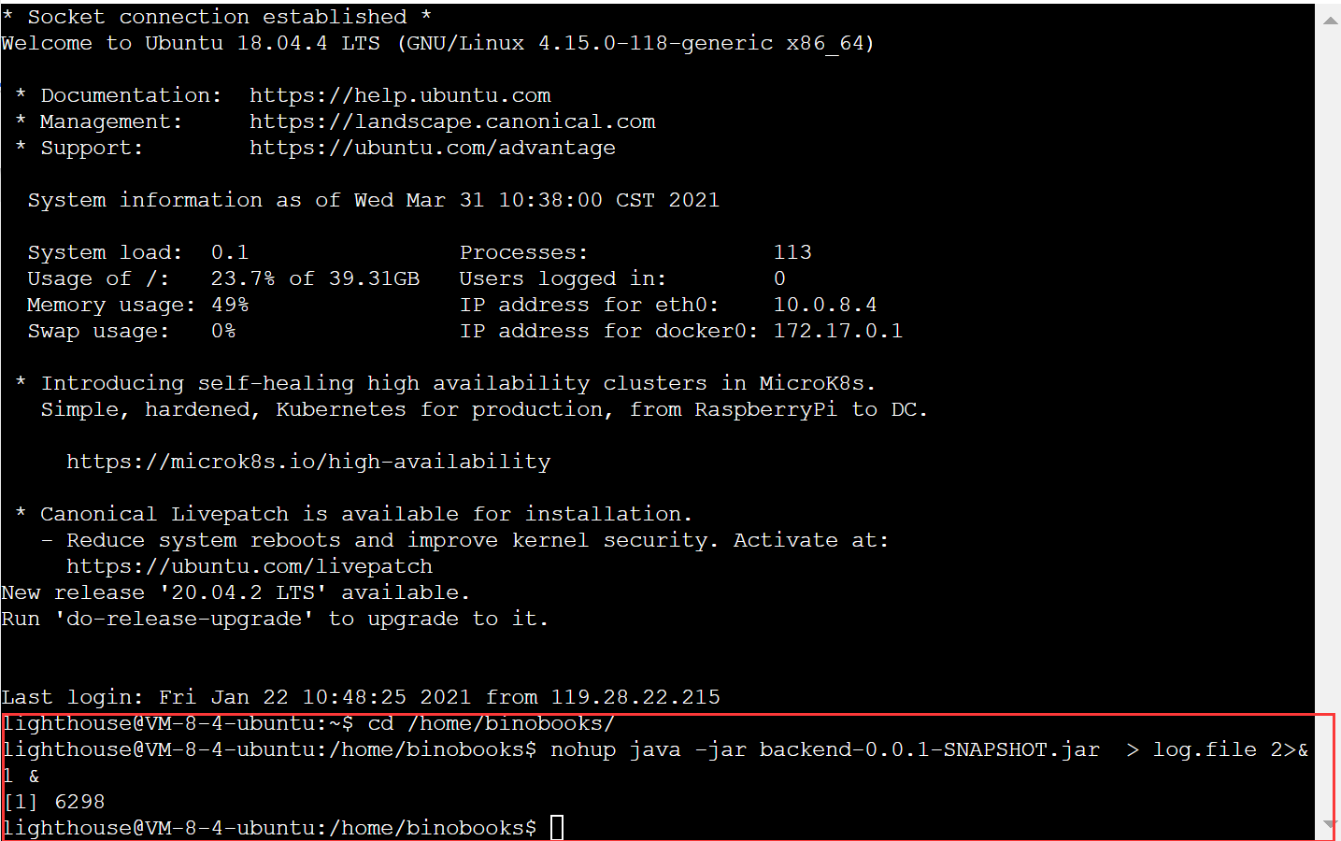

We can test if our backend works by sending a request with Postman. Remember to replace your server IP address in the red rectangle. And if we see the desired response, which means it works correctly.

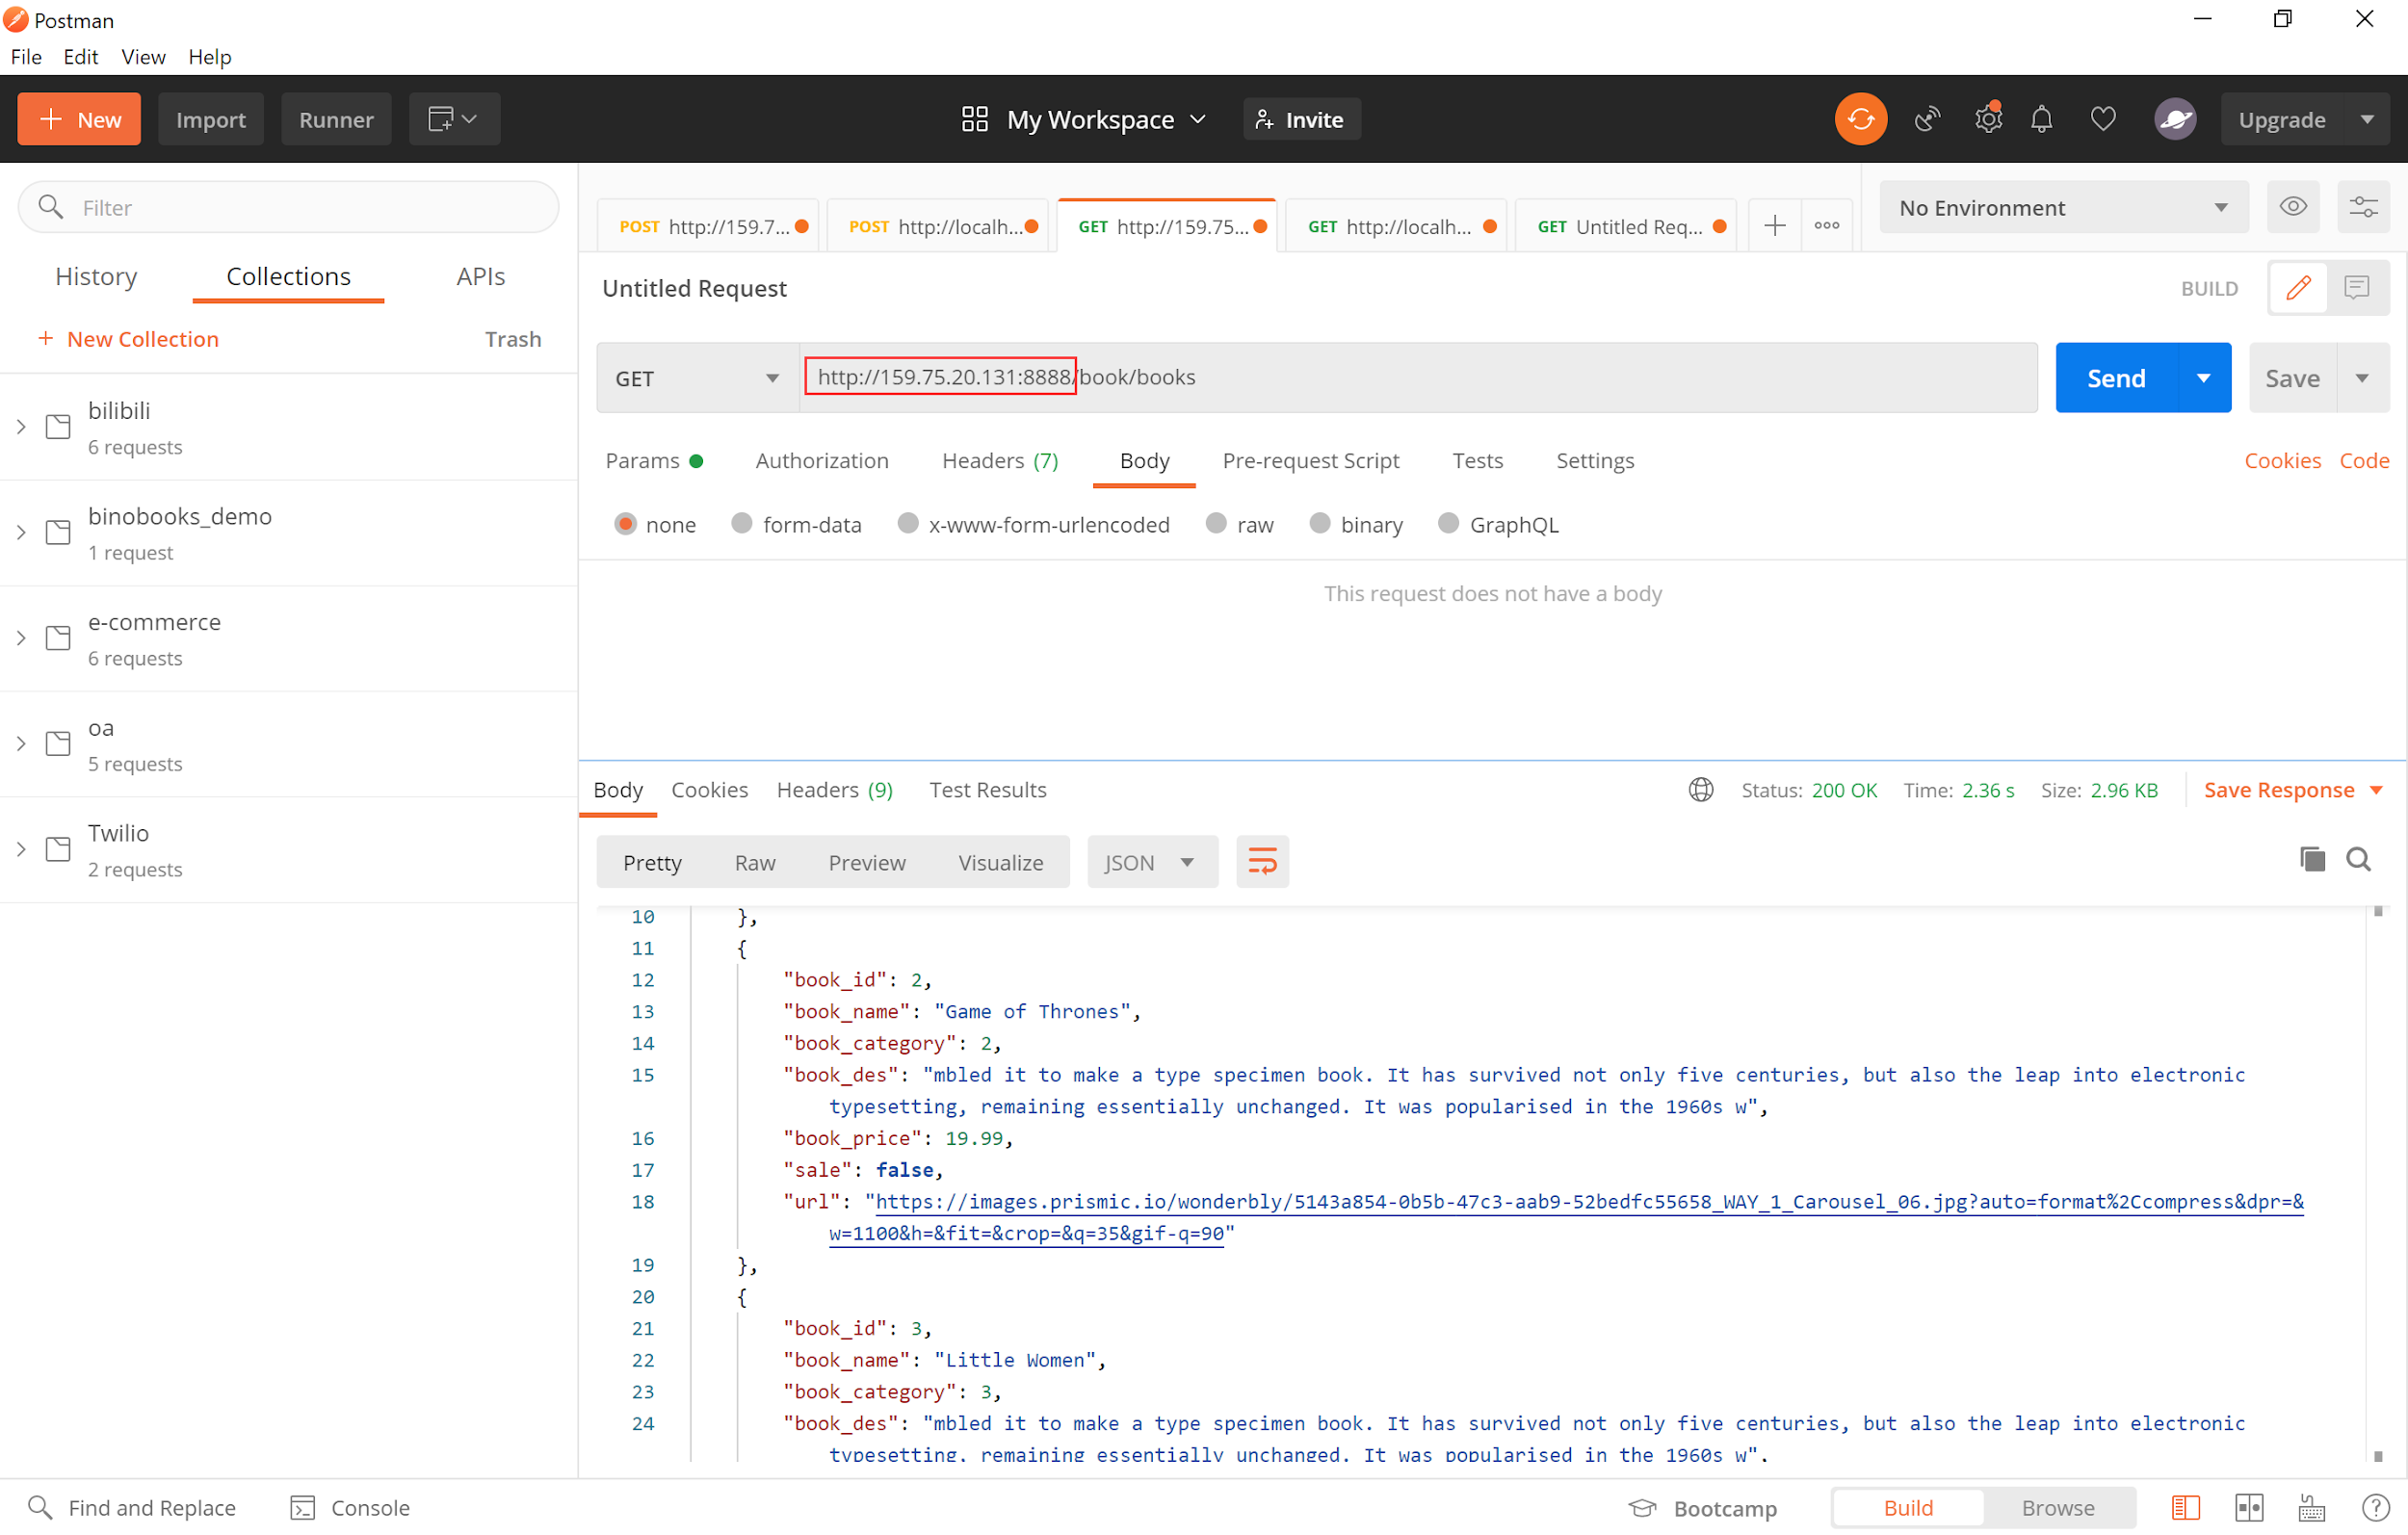

#### 1.1.2 Frontend

##### Code Setup

Vue 3.0 does not build up with the config folder, so we have to create *vue.config.js* in the root manually. You may also want to change the port number to some other value.

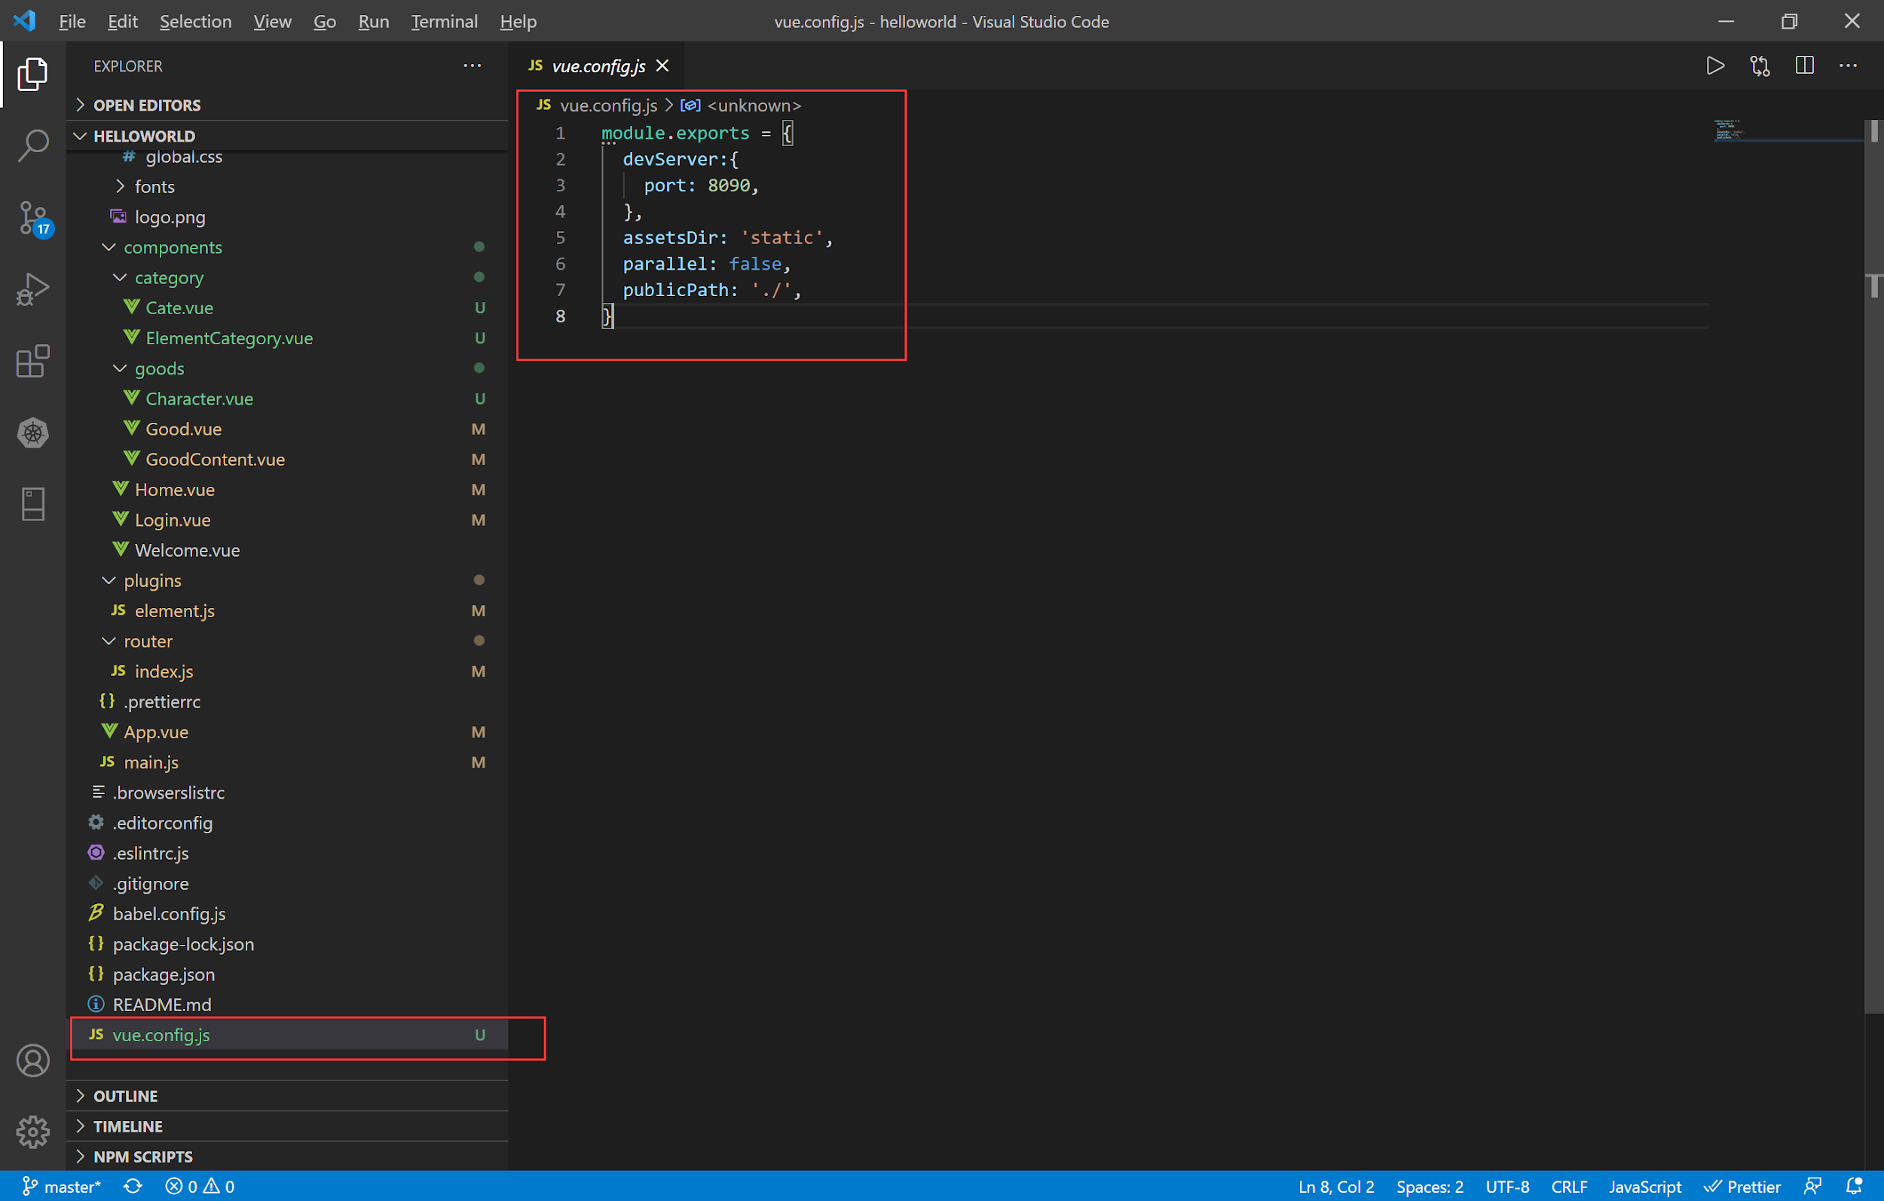

execute the command in the terminal:

npm run build

then the stuff in the dist/ directory is what you want to put on the server. You may also want to rename the folder and give it a new meaningful name. Here we change it to admin.

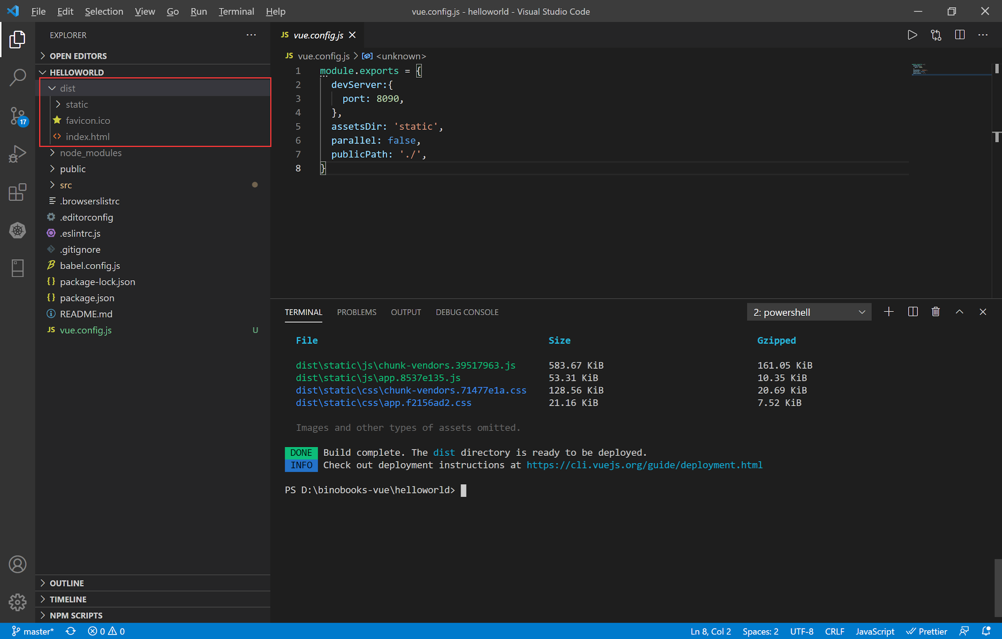

##### Server Setup

Compared to deploying the backend code, the frontend code is easy to deploy. we only need to put it under the tomcat webapps folders.

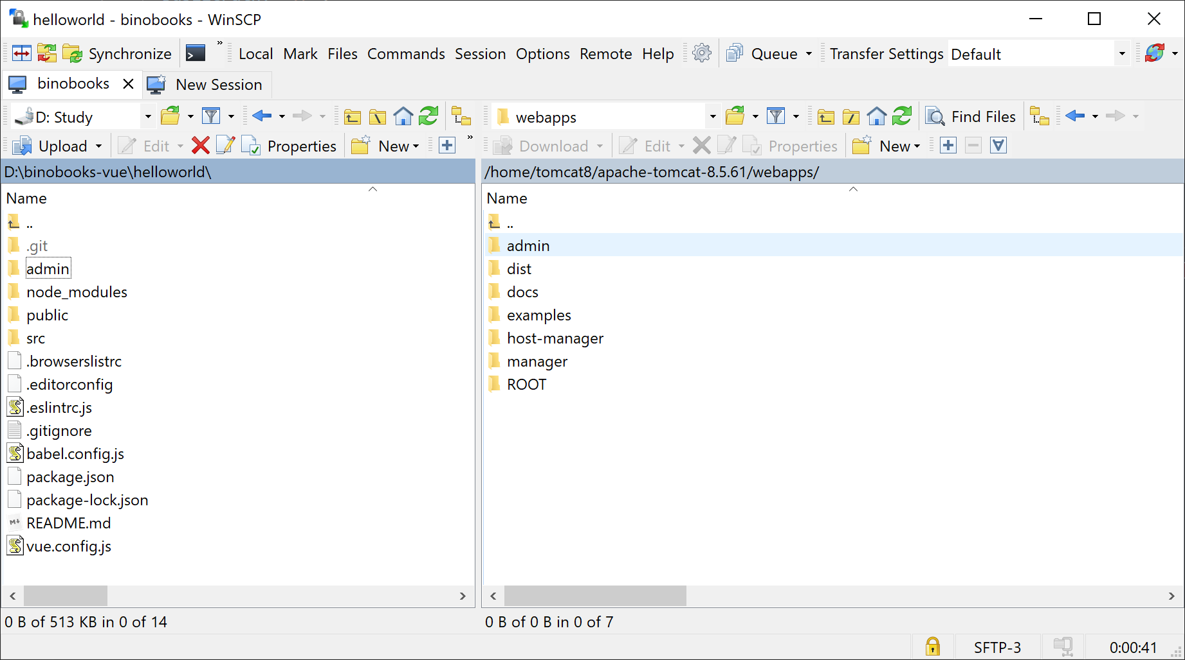

##### Access the Website

You shall be able access the website through “server IP:port/your folder/index.html”

## Maintenance Suggestions

1. The backend server allows web administrators to manage the e-books. Administrators need to make sure the books sold online are up-to-date. The website copyright is current and the e-books provided are all available.
2. As for web safety, web related files like character elements now store in the Minio Server. We recommend making a backup of the character elements and the site database. To better prevent any data loss or being hacked by the third party, this is a necessary step to backup all the web files in not only one place and to any external reliable locations. Besides, we recommend the backup frequency is once a week.
3. The backend server is built with some external dependencies like Minio server and page helper. The current version we used is set up in *pom.xml*. Make sure to use the suitable version of those dependencies. Updated versions of Minio server and page helper need to be consistent with the whole web system.
4. We suggest the owner check the log file regularly. The log file is a good place to look for when debugging and refining the code.

## Limitations and Workarounds

#### UI Design

1. Images are restricted to the same size.

Cover images of books are required to have the same size, in order to avoid overfitting and layout problems.

1. Book Detail Page Modification

Although the All Books page and books by category pages have a similar layout, they are different pages(different files). If the administrator wants to change the layout for any of the four pages is required to change all four pages.

1. Incomplete word short description.

In order to limit the length of the short description on a product card, the short description is limited by letter count, therefore the short description may have incomplete words.

1. Hairstyle and skin tone option is required

At least one hairstyle and skin tone option is required for customers to continue purchasing. If none hairstyle or none skin tone is available for selection, the preview button is disabled since hairstyle selection and skin tone selection is essential to enter the preview page.

since cart information is stored in local.

1. The text in the different line should be set individually, since the built-in function does not support newline character
2. The length of the book name shall be in the range of 3 to 63. The restriction is introduced by the MINOI bucket. More constraints can be viewed [here](https://docs.rightscale.com/faq/clouds/aws/What_are_valid_S3_bucket_names.html#:~:text=Bucket%20names%20should%20be%20between,%2Dbucket%20are%20invalid)).

#### Adapativity

1. Book preview page is disabled after website refresh.
2. Download link is not recoverable after closing the confirmation webpage.
3. The pages are not fully adapted to mobile devices.
4. Admin system only supports upload, modify elements one by one, so after clicking save for an element. Any changes to other elements will be discarded

#### File Storage

1. Cart feature requires local storage

Local storage is required on the customer's device while using the cart feature

#### Portability

1. The page does not adapt to mobile devices. To get the best display effect, please use your PC.

## Updates to previous documents

As for the change in functional requirements, we did not implement the login function for the customer. We instead implemented the function of managing the customer.

We did not implement the payment service so that we could implement order functions neither, but the order can be accessed through the customer management system. Instead of sending the customized book to customers’ emails, we provide a link for customers to download it.

We also make some changes in the architecture design. Instead of choosing microservices architecture, we choose to build the front end and back end services on only one server. Besides, we did not choose to apply some of the supplementary plugins which we mentioned in the design document, such as RabbitMQ, Nacos and Reids.

## References

1. https://searchsecurity.techtarget.com/definition/authentication
2. https://auth0.com/docs/tokens/json-web-tokens
3. https://en.wikipedia.org/wiki/Authorization

## Work Distribution

|  |  |
| --- | --- |
| Tongxu Ge | Developer Manual, Maintenance Suggestion |
| Mason Chang | User Manual, Limitation and Workarounds |
| Shengan Li | User Manual, Developer Manual |
| Yueyang Liu | User Manual, Developer Manual, Installation Guide, Maintenance Suggestion, Limitation and Workarounds, Updates to Previous Documents |